Medieval Bestiaries:
A Look at the Medieval Owl

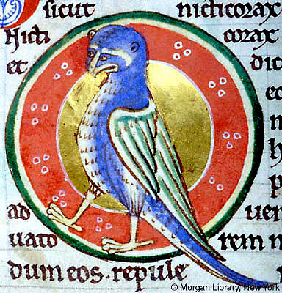

Libby McArthur
Governor’s State University
April 2011

Table of Contents

Introduction 3
Medieval Bestiaries 3-5
Origins and Families 4-6
Religious Implications 6-7
Illustrations 7-9
The Owl 9-12
Conclusion 12-13
Works Cited 14
Figures 15-20

Introduction
Noctua, Bubo, Bubone, Chouette, Hulotte, Nicticorax, and Night raven are just a few of the over 25 names used to describe the owl during the Medieval Ages. These creatures were mentioned in the bible and written about in the animal encyclopedia known as bestiaries during the medieval period. The owl takes on a persona that is both dark and menacing. It is drawn in great detail to characterize the moral allegories for which its story portrays. The owl becomes the embodiment of the darkness and the people who chose that darkness over Christ (Badke).

Medieval Bestiaries
During the middle ages, the written word becomes a tool in which the beliefs of the day were poured into books by monks and scriptoriums. These books become immensely detailed and were being painted with elaborate designs and filigree. Paints were used to highlight their ideas and even gold leaf was added to make the pages glow with importance. Illuminated Manuscripts were most commonly used for the “word of God” to bring spiritual morals to the masses and upper class. However, during the 11th and 12th centuries, stories of animals were extremely popular in Europe, North Africa, and the Middle East. This may have come to be because man was dependant on them for their survival and everyday life. Domestic and wild animals began to take on moral aspects and even mythical powers. These stories of animals and moral obligation were written into illustrated collections of animal encyclopedias known as bestiaries.
The bestiary was a compendium of the beasts and common animals talked about during the middles ages. These books contained illustration, natural histories, and moral lessons that usually accompanied the animals. The animals in the bestiaries included real and mythical creatures, like unicorns, griffins, sirens, and many others. Despite the interest in the knowledge of the animals during this time, there was more to it than that. The bestiaries had many religious symbols and allegories associated with them.

Origins and Families
Animals were being written about long before the Middle Ages. It was Christianity, however that took these stories and turned them into moral allegories. The first known animal publication was known as the Physiologus No one is sure who wrote the work, but date it is attributed to being in Alexandria during the third or fourth centuries. Alexandria is believed to be the origin because of the animals that are talked about in the forty eight chapters. Professor Michel Curley writes,
“the anonymous author of the Physiologus infused these venerable pagan tales with the spirit of Christian moral and mystical teachings, and therefore they occupied a place of special importance in the symbolism of Christian teachings” (ix).
Consequence, the translated title is “naturalist” however this can be misleading because it is not a book of natural history but rather a book on Christian symbolism (Hassig).
The Physiologus was the basis for the medieval bestiary because of its collections of stories, as well as the moralization that it connected to the animals. This book became the most widely distributed book in Europe after the Bible. No originals of the Greek text survive, however early versions of the Latin translations are still with us today.
Today scholars, professors, and historians have found similarities in certain bestiaries and have begun to classify them into families. The first system of classification is that of origin/language English and French being the large groups. Another group would also include Italian, Catalonian, and Castilian. England had the more success with bestiaries that any other country (Hassig 2). In 1928, M.R. James pioneers a 4 class classification of English bestiaries into families. This classification was based upon the size and textual content of the bestiary. In 1962, Florence McCulloch modifies James’s families by breaking down the first family into sub-families. French manuscripts are broken into families based upon the author, who is usually known. Many of these families are still argued today by researchers.

Religious Implications
Many believe bestiaries were associated as scared books of faith. The medieval period was distinctly religious, the church and pray played a large role in every walk of life. Wars were even fought on the religious beliefs of a people. Despite the sometimes hostile differences between the Jewish, Christian, and Islamic religious views; these groups are closely related and share many of the same spiritual and historical texts. The Old Testament in particular is utilized in some way by all three religions. It refers to animals in many ways including;
"But ask the animals, and they will teach you, or the birds of the air, and they will tell you; or speak to the earth, and it will teach you, or let the fish of the sea inform you. Which of all these does not know that the hand of the Lord has done this? In his hand is the life of every creature and the breath of all mankind." (Job 12:7-10).
This excerpt from the Book of Job is a great example of the animals being seen as being sacred and created for a reason. Many believe God made these creatures for a specific purpose and to reinforce certain moral attributes. David Badke writes, “As the pelican revives her dead young after three days with her own blood, so Christ revived humanity with his blood after three days in the grave”. The pelican is not the only animal with Christian beliefs attributed to it. The eagle and hoopoe are also portrayed in a religious light. The young hoopoe cares for it elderly parents, just like a human children should care for the elderly parents. The eagle is known to reject its young that flinches when staring directly in the sun. This becomes a metaphor for God rejecting those who cannot stand in divine light (Badke).
Illustrations
Bestiaries were nearly always illustrated. References from earlier descriptions and drawing would aid the artist to accurately depict the animals and thus making them recognizable to the masses. Sometimes the illustrations become quite lavish in the case of the Harley Bestiary and the Aberdeen Bestiary. Badke remarks, that these illustrations were a way to visual communicate with the uneducated or illiterate. The bestiaries also aided in stone workers to carve the beasts in capitals, porticos, and other various medieval decorations. Great Tapestries of animals were woven and placed on display showing the moral implications the bestiaries wrote about.
However not everyone agreed with the idea of illustrating the words and the abundance of animal imagery that followed the bestiaries. In his Apology around 1127, St. Bernard of Clairvoux writes:

"What profit is there in those ridiculous monsters, in that marvelous and deformed comeliness, that comely deformity… In short, so many and marvelous are the varieties of shapes on every hand that we are tempted to read in the marble than in our books, and to spend the whole day wondering at these things rather than meditating the law of God. For God’s sake, if men are not ashamed of these follies, why at least do they not shrink from the expense?"

St. Bernard, being one of the founders of the Cistercian order, found the need to decorate as a want and not a necessity there fore was a frivolous in devour. In other words man’s work could be done better elsewhere. A contradiction when he himself has been placed in many illuminated manuscripts (Figure 1) and paintings.
The illustrations of the artists were mainly non-realistic. Not only because many of animals did not really exist but because the artist could not get accurate specimens of the ones that did exist. For examples, whales were often depicted as large scaled fish and ostriches often had hoofs. In figure 2, a whale is depicted with scales and gills. Also the tail is in a vertical position when whales like dolphins have a horizontal tail. In the monasteries the monks would have no way to access the information about the skin and tail of a whale. Also the monk doing the illustrations might be the best artist at the monastery but was not trained to be an accurate artist. Some animals, like the owl, were even given human attributes because of the religious implications.
Vivid colors were used in many of the bestiaries. Gold Leaf would be added to create a sense of importance and grandeur. In figure 3, a page from the Aberdeen Bestiary creates a sense of luminance from the gold leaf used in the background of the creature illustrations. The animals appear to rotate and ungulate as the break free of the frames that surround them. This page of serpents would have been expensive to produce which proves that there was a sense of importance that was placed onto these books and through that the illustrations.

The Owl
The medieval bestiaries were no stranger to the owl. Several kinds of owls were described in the most complete bestiaries. The three most common were noctua, the night-owl, that lives in the walls of ruined houses and shuns the light; nicticorax, the night-raven; and the bubo, the common owl, a dirty bird that pollutes its nest (Badke). Most often the owl was viewed with a negative connotation, with a feeling of an impure animal. However in the Aberdeen Bestiary the noctua or night owl is seen in a more positive light, but the other 2 owls are seen more negatively. The Aberdeen Bestiary reads;
“Isidore says of the owl: 'The name owl, bubo, is formed from the sound it makes. It is a bird associated with the dead, weighed down, indeed, with its plumage, but forever hindered, too, by the weight of its slothfulness. It lives day and night around burial places and is always found in caves.'”
The Bubo (Figure 4) is commonly associated with the dead because they come out at night and have been known to live near graveyards and in tombs. This would have given them an evil aura. This owl usually is representative of the sinner who shuns the light and turns to the darkness. Aberdeen Bestiary also states, “For it lives in caves like the sinner who will not emerge from darkness by means of confession but detests the light of truth”. The light is god and the owl has chosen to turn away from it because it is afraid or to be “slothful”. The owl is also referred to as a sinner because it pollutes it’s nest much like a sinner pollutes the people around them it through their evil ways (Aberdeen Bestiary).
Due to the direct abandonment of the sun and in turn, God, the owl has been viewed as an anti-Jewish symbol. Dabke writes, “The owl in general represents the Jews, who showed that they preferred darkness to light when they rejected Christ”. The bubo goes even further through illustrations by creating an owl with anthropomorphic take on the physical form of the Bubo. In Hadley 4751 (Figure 5), the owl face becomes distorted to represent a common Jewish portrait. The most often used feature that is changed is the beak. It is usually transformed down, into what appears to be more of a hooked nose feature than an actually beak. Also the eyes begin to change. They appear to have an almond shape which is a human characteristic. Eyebrows have also appear over the owls eyes and attach to the beak/nose.
Also in the Hadley 4751 illustration (Figure 5), the owl is being shown in a scene where it is being tortured by other birds. According to Miyazaki, the attacking of the owl shows that the Bubo or other owl is being attacked by more virtuous birds, this represents how the Jewish people are hated by the Christians. Miyazaki also writes that in Bodley 602 (figure 6); an owl is shown with its eyes closed and peaking at a corpse in the ruins of a temple. This temple is related to the ruins of Babylon and the fall of the Synagogue and in turn the “Old Law” (28).
Many other owls are given human facial attributes during the time of the medieval bestiaries, but the most prominent feature was the hooked nose/beak (Figures 7 and 8). Sometimes the beak would not be a beak at all but more of a nose because the mouth was drawn underneath it (Figure 9). This figure also has humanistic, almond shaped eyes and eyebrows. These eyebrows meet the nose and continue down along towards the mouth of the creature.
Despite all the negative light being cast at the owl during the medieval period the Aberdeen Bestiary does have one owl that is being shown in a positive manner. The night owl or noctua is said to signify Christ. It makes the connection using this statement; “Christ loves the darkness of night because he does not want sinners - who are represented by darkness - to die but to be converted and live” (Aberdeen Bestiary). The book goes on the relate Christ living in the cracks of walls to him wishing to be born of the Jew people but in turn ended up being killed by them. It is also said the just as the owl flees from light, “[Christ] He flees from the light, in the sense that he does not look for the glory of human praise” (Aberdeen Bestiary). The moral lesson being that Christ did not seek the light of fame, nor should you show too much pride and vanity. The line that sums up the owl being linked to Christ is “The night-owl flies at night in search of food, as Christ converts sinners into the body of the Church by preaching”. The owl shown under these descriptions (Figure 10) is shown with more of an owl body and face then most of the other owl that appeared during this time.
It is odd despite all the negative connotations that a positive personification where the owl is compared to Christ himself would surface. Misericords were commonly depicted in churches with owls carved into them. These owls were most often displayed being attacked by other birds. In figure 11, an owl with a hooked beak is being mobbed by birds also carved into the wood, referencing the hatred towards the Jewish people.
Conclusion
During the medieval times the written word was becoming more common and more people were becoming educated. Many of the books being written and illuminated were religious in nature. The medieval bestiaries were no exception. This moral tales of animals were brilliantly illuminated and lavishly drawn in most cases. However these drawing were not often accurate. Many animals were drawn inaccurately including the owl, but this subject is under debate. Were common animals purposely mis-drawn like the owl for secondary meanings?
The owl received a beak that was hooked, and a face that was in transition between that of an owl and that of a human. In many illustrations the owl was seen being attacked by other animals. Due to the hooked beak and mobbing by other birds many have come to the conclusion that the owl is a reference to an anti-Semitic view. Some bestiaries like the Aberdeen Bestiary actually write it, “This bird symbolizes the Jews who, when the Lord our Savior came to save them, rejected him”.
In most cases the owl was the personification of the hatred of the Jewish faith; it was written and even carved into the churches themselves in the form of misericords. However the owl is given the highest honor by the Aberdeen Bestiary when it compared the night owl to Christ;
“The night-owl keeps watch in the night, as when the righteous man, alert to the darkness of sinners, avoids their errors... it seeks food by night, as when he reflects upon the life of sinners and uses their example to nourish the mind of the righteous”.
Either good or bad the symbolism and moral value of the owl is important to the people of the medieval period.
Works cited
Curley, M., Physiologus: A Medival book of Nature Lore. The University of Chicago Press, 1979, Chicago

Babke, D. The Medieval Bestiary; Animals in the Middle Ages. Last updated 2011. Retrieved from http://bestiary.ca/index.html.

Hassig, D. Medieval Bestaries:Text, Image, Ideology. Cambridge University Press. 1995.

Miyazaki, M. Misericord owls and medieval anti-semitism by: in Debra Hassig, ed., The Mark of the Beast: The Medieval Bestiary in Art, Life, and Literature, New York: Garland, 1999, 23-49
Physiologus, trans. M.J.Curley, Austen, 1979.

St.Bernard of Clairvoux, Apology of about 1297

The Aberdeen Bestiary Project (Aberdeen University, 1996) http://www.abdn.ac.uk/bestiary/history.hti

The English Standard Version Bible: Containing the Old and New Testaments with Apocrypha. Oxford: Oxford UP, 2009. Print.
Figures
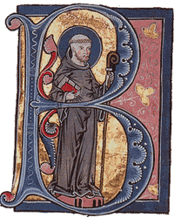St. Bernard of Clariux, Figure 1
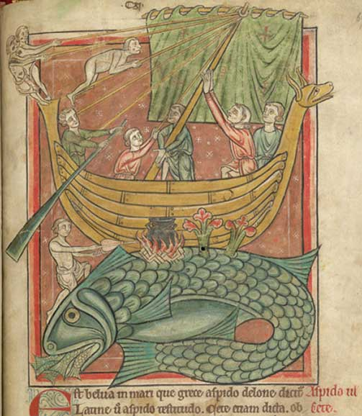 Whale illustration, Figure 2
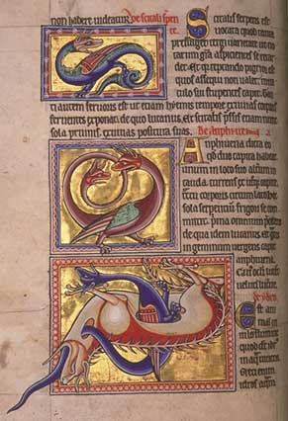
Page from Aberdeen Bestiary Figure 3
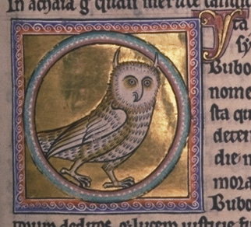 Bubo (Aberdeen bestiary) Figure 4
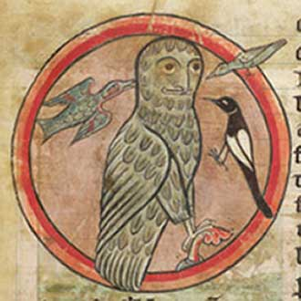 Hadley 4751 Figure 5

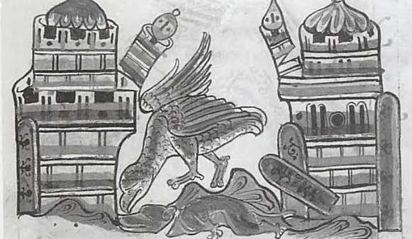Bodley 602 Figure 6
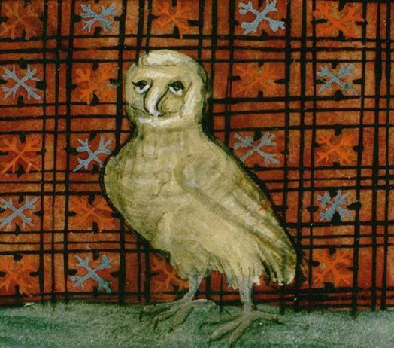
Bibliothèque Municipale de Reims, ms. 993, Folio 153r Figure 7
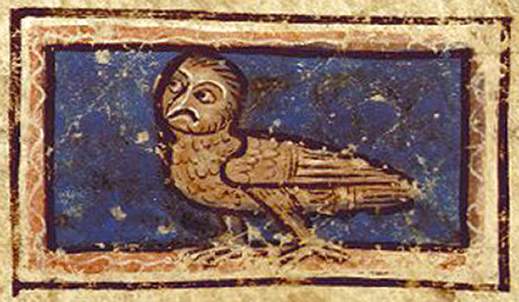
Bibliothèque Nationale de France, fr. 1444b, Folio 243r Figure 8
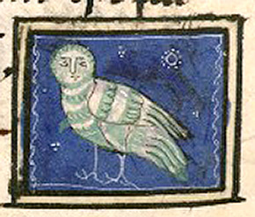
Bibliothèque Nationale de France, lat. 14429, Folio 105v Figure 9

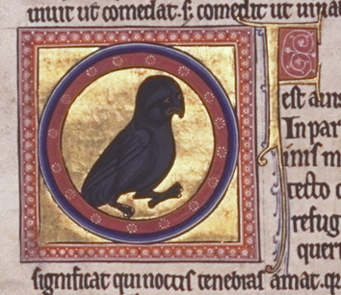
noctua (Aberdeen bestiary) Figure 10
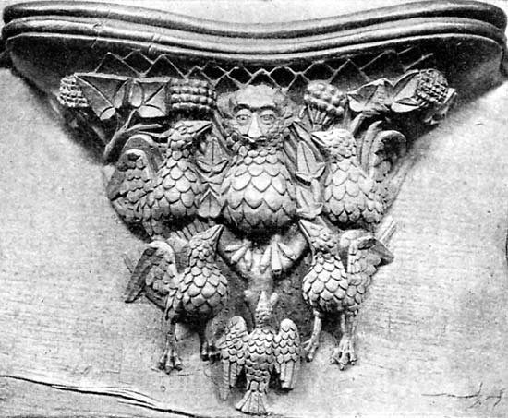
Misericord; Norwich Cathedral, Norwich, England Figure 11

