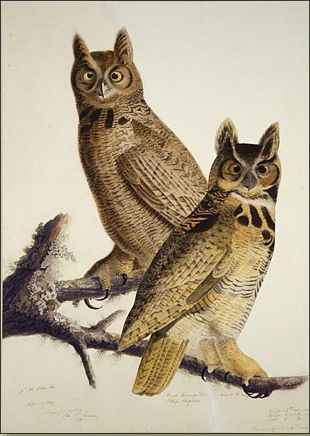

John James Audubon: A Look at the Artist

Libby McArthur
Art 805
April 2012

Table of Contents:

Introduction 3
Early Life 3
The Businessman 4
The Artist 6
The Birds of America 8
His Legacy 12
Conclusion 13
Figures 14
Works Cited 21

Introduction
John James Audubon is a name synonymous with wildlife preservation. In 1095, a non-profit organization, called the National Audubon Society was formed. They sought the conservation of birds, other wildlife, and healthy ecosystems. The society still remains an active part of the wild-life movement. However, John James Audubon was not always what his name might suggest.
Audubon was an adventurer and mad scientist all rolled up into one. He sought every day to better his skills as an artist and as an ornithologist by studying birds. Throughout his life and career, Audubon killed thousands of birds to research there movements and behaviors. Creating new techniques for animal drawing, Audubon blurred the lines between anatomical drawing and fine art. His larger than life personality and his tall tales, cause Audubon to make enemies in the North America on his path to greatness.
Despite opposition, America’s backwoods artist did achieve great things during his time. He found many new species and subspecies of birds, documenting them for the world to see. He also documented and observed 6 species that are now thought to be extinct, including the Caroline Parakeet and the Passenger Pigeon. He also was responsible for giving the view glimpse of America during the 1800’s. John James Audubon’s Birds of America gives the viewer a chance to remember a much simpler time when the wild was undiscovered and undisturbed. Audubon did become an important figure in both conservation and as an artist.
Early Life
On April 26th 1785, John James Audubon was born to Captain Jean Audubon and Mademoiselle Jeanne Rabine, his French chambermaid. He was born in Saint-Domingue (now Haiti) at the planation his father owned where his father made his fortune as a merchant, planter, and dealer of slaves (Souder 18). Little is known about his mother, except that she was Creole and died soon after giving birth to her son. Captain Jean Audubon was not married to Mademoiselle Rabine which made John James an illegitimate child. In 1788, at the age of three, Audubon was brought to Nantes, France to live with his father and his wife. He was adopted, with another half-sister in 1794.
His father tried to ensure that Audubon was given a proper education by sending him to school to study mathematics, geography, drawing, music, and fencing. His father would take him walking and teach him bird names. A doctor friend of his father's taught him anatomy and dissection, skills he would use often later in life. According to Audubon’s own writings, he had no interest in school, but preferred to stay outdoors exploring, hunting, and fishing. This made him resist all efforts to keep him in school and under control while his father was away on his naval officer duties. At the age of twelve, Audubon went to military school. He found out that he was susceptible to seasickness and uninterested in the study of navigation or mathematics. After failing the officer's qualification test, he briefly went to study art in Paris, and didn’t like that either (Streshinsky, 13).
The Businessman
In 1803, John James Audubon obtains a false passport from his father and leaves France to travel to the United States. This was to avoid conscription into Napoleon’s army. After catching yellow fever and being nursed back to heath by Quakers upon arriving in the United States, Audubon moved on towards Pennsylvania and his father’s farm at Mill Grove, near Valley Forge. His father intended for him to live with friends of the family and while he learnt English. However, after a short period Audubon demanded to live on his own at his father’s estate.
To Audubon this life was paradise, he wrote, "hunting, fishing, drawing, and music occupied my every moment; cares I knew not, and cared naught about them" (Rhodes, p.5). His room was filled with eggs, nests, and taxodermied creatures. He would spend hours outside watching and writing down bird behavior, which was a habit that Audubon would continue with the rest of his life.
In April 1808, Audubon married the daughter of a neighbor, Lucy Blackwell. They then headed west to Louisville. In Louisville, Audubon and a friend, Ferdinand Rozier opened a general store near the Ohio River. After two years, he moved to Henderson, Kentucky to escape the competition of Louisville. He also owned a store in Illinois and quickly became one of the wealthiest people in the area. After the panic of 1819, banks began to call in loans from everywhere. This led Audubon to be thrown into a Louisville jail for outstanding debts. His wife Lucy suffered the most from this incident though. Their house was stripped of everything they owned, including all her family’s heirlooms which she had intended to pass down to her children. Even Audubon's drawings were put up for auction, but nobody wanted them, so in the end he was allowed to keep them.
After his stores and steel mills failed, he had no money or house, essentially nothing but his family and the clothes on his back. He always said that it was his own fault his business endeavors failed. He claimed that he never put his whole self into them, because his mind would always float back to his birds. So in 1820, Audubon decided to leave his family behind and head down the Mississippi River to New Orleans to follow his dreams. He would create a complete ornithological guide to the Birds of North America.
The Artist
Audubon, since a young age, found drawing and bird watching were much more interesting than his school and naval studies. He preferred being outdoors looking at birds and adventuring. Upon arriving in the United States, Audubon found himself developing a new way to hone his skills. He found that by inserting wire into the bird he had killed he was able to capture more realistic, dramatic positions. This would lead to more interesting compositions when creating his famous work, "The Birds of America". He would kill hundreds of birds in order to find good specimens. He referred to himself as the two legged monster armed with a gun that walks into a scene and destroyed it in the hopes of creating a scene that was life-like.
He would work in a two-dimensional plane, where he would pin a dead bird to a board with a grid system. He would stretch the birds into life-like mannerisms and dynamic positions. The he would work meticulously to accurately draw and then watercolor his creation onto the paper. This way of working creates a contradiction with the popular conception of the name Audubon, in the present day it is known for conservation and preservation of nature, when in reality he was killing many birds to create his paintings.
Alexander Wilson visited Audubon in Louisville, while he was canvassing for subscribers to the first American Ornithological book. Before Audubon had a chance to subscribe to Wilson's book, his friend and business partner, Rozier told him, in French so Wilson could not hear, not to because his drawings were better than Wilson's. This did not sit well with Wilson, so he asked to see Audubon's work. He pulled out a full color portfolio to show Wilson his whole collection. Wilson was surprised and astonished by what he saw, he had no idea that anyone else was also taking on similar work (John James Audubon: Drawn from Nature).
In comparison Wilson's work (Figure 1) when compared to Audubon's look almost cartoonish in comparison. When one looks at the Snowy Owl by Wilson, it is reminiscent of the bubo owls seen in medieval manuscripts (Figure 2). The snowy owl stands too erect with eyes placed under large hooded brows. When looking at a photograph of a snowy owl (Figure 3), the owl stands hunched over with the body slanted at about a 45 degree angle over the feet, with the head standing at 90 degrees to the front of the body, much like other birds. Audubon’s depiction of the Snowy Owls (Figure 4), finds the birds in a much more believable position. Audubon’s drawing also has a maturity of background and setting that Wilson’s does not. Wilson’s Owl is perched on a branch that he appears to be about to slip off of. There is an eagle or hawk in background, which is typical of the Wilson style to place several birds on one page, whereas Audubon usually dedicates a whole painting for each species. Audubon’s Snowy Owls, is also one of the few night scenes that he creates, which lends himself to be more true to the owls behaviors.
In 1820, after Audubon’s business ventures failed, he decided to explore America and complete his inventory of all the bird species of American. In 1821, when he arrives in New Orleans he begins to create charcoal portraits for money, even risqué nude portraits. After making enough money painting portraits, he brings his family to Louisiana. There Lucy becomes a school mistress on a plantation and supports Audubon in his pursuit of the birds so that he may complete his book.
It is here that Audubon begins to look deeper into the soul of the bird. He explores different types of media, branching out into pastels, oils, and washes to bring the bird to life. Audubon becomes very particular with the tools he uses to capture his beloved birds. By making his own brushes he is able to control the thickness, pressure, and movement of the lines. He was even known to make brushes with only a single strand of hair to capture the minutest detail. He would outline every single barbule in every single feather in iridescent graphite. This is noticeable in "Carolina Parakeet"(Figure 5). As you turn the painting toward the light every strand will glow and sparkle from the graphite lines that Audubon has careful drawn.
At this time Audubon also discover the use of storytelling within in his work. The birds begin to display emotions, good and bad, fierce or playful. This brings the work of Audubon to a new level and brings new interest in his art. The naturalists hate this new found emotion because it turns away from the scientific method of drawing animals for study and anatomical perfection. However the public find his style of creating intimate moments, like a mother wild turkey with her chicks (Figure 6), endearing and generates an emotion attachment to the work.
The Birds of America
In 1824, John James Audubon turns thirty nine and decides leave his family and Lucy to show the world his work. He traveled up the Mississippi and Ohio rivers towards Philadelphia and onto the Academy of Natural Sciences. Audubon arrives in Philadelphia in the hopes of obtaining support for the publication of his engravings of American birds. Unfortunately his personality gets in the way. His larger than life stories and big personality begins to ruffle feathers while he is there. While showing off his artwork, his cockiness comes into full affect when he compares himself and claims himself to be a better artist than Alexander Wilson. Comments like these don’t sit well with some of the members of the Academy of Natural Sciences. George Ord, editor of American Ornithology by Alexander Wilson, found great contempt for Audubon and campaigned against him. Ord felt that Audubon’s hick like appearance and manner shamed the memory of Wilson’s American Ornithology. After the Academy of Natural Sciences declined to support Audubon’s efforts, he quickly realized he would have to go elsewhere to pursue his publication (John James Audubon: Drawn from Nature).
In May 1826, Audubon leaves on a boat filled with cotton and one ornithologist on a two month crossing of the Atlantic towards England. On the trip, Audubon spends much of his time sketching the crew and writing his thoughts. When he arrives in England he quickly becomes a huge success. Within 10 days of arriving in Liverpool, he has already exhibited 250 paintings at the Royal Institution. This show then travels to Manchester and Edinburgh. His paintings get nothing but the best reviews and highest praises (John James Audubon: Drawn from Nature).
Audubon quickly discovers that all the reason’s people disliked him in Philadelphia is the reason why the people of the United Kingdom love him. The English see him as this exotic creature. His life-sized, colorful, and dramatic paintings hit just the right note during the continent’s romantic age. Audubon writes, "I have been received here in a manner not to be expected during my highest enthusiastic hopes" (Rhodes). Audubon plays up the “American Huntsman” angle or the noble man of the forest, and tells his tall-tales and captures his client’s hearts. However, Audubon is deeply ashamed of his background and illegitimate birth. He becomes scared that if the English gentry were to find out then his possibility of support and publication would dissolve in an instance.
He quickly becomes a one man show to get backings and subscriptions to his Birds of America, which consists of 435 hand-colored, life-size prints of 497 bird species, made from engraved copper plates of various sizes depending on the size of the image. While in Edinburgh looking for subscriptions Audubon meets William Home Lizars who agreed to publish Birds of America. While working on the first set of engravings, there is a strike, which forced Audubon to move the production to London. In 1827 Audubon met Robert Havell Jr., who then became the engraver for the project.
Havell & Son quickly get to work on the double elephant folio etchings using aquatint. After the originals were traced and transferred to copper plates, the engraver would then go over every lines and detail with a needle tool. Each plate weighing about thirty pounds would then be soaked in acid and cleaned. Ink would then be applied to the plate. The plate would then be printed on sheets measuring about 39 by 26 inches, creating the perfect canvas for the life-sized drawings. Over 50 Colorists were hired to hand color each print in an assembly line process (Rhodes).
From 1826-1939, one hundred and eighty five complete life-sized were completed and finished. The double elephant folio was a massive book that came in two parts. The images were grouped in fives with a large painting meant to dazzle at the end. Due to the size of the folio it would often need several people to show the massive work. The total price of printing the entire work was $115,640 or over $2,000,000 today, which was paid for by advance subscription of the book. With a hefty price tag only the wealthy subscribed to the work, including the King and Queen of England and France.
Over the next 13 years, Audubon wandered the wilds of North American continuing to find new birds to draw and add to his book. He also decided to write a semi-fictional memoir, Ornithological Biography. This publishing of this book brought him more fame and an opportunity to meet President Andrew Jackson. Through his travels, Audubon saw the death of species and a waste of America’s pure resources. He often wrote about his fear that his beloved country could turn into London, covered in dirt and smoke.
In 1833, Audubon bought a large golden eagle to complete his next drawing. It was a magnificent bird with large golden eyes, like the eagle in Figure 7. Audubon was not sure how to kill the creature so he could create his model in order to complete his painting. He first decided to smoke it to death. So he began to smoke the bird, however after returning hours later the bird was still alive and just stared at him. He then decided to add sulfur to the smoke, but once again when he returned hours later the eagle was still staring at him. He was stuck; he wasn’t sure how to kill the bird without ruining its feathers. He finally decided that a metal pin through the heart would kill the bird quickly. Once again he looked into its golden eyes, but this time he killed it at a great cost to his conscience.
Figure 8 is the Golden Eagle painting that was done from the golden eagle that Audubon killed to make his art. Audubon wrote in his journals about how this painting was the hardest of his life. Especially since when painting it he felt at one point that he was going to die. He often remarked how the painting almost took his life. If the viewer looks at the background of Audubon’s Golden Eagle painting, they will notice the man traversing a gorge (Figure 9). Audubon painted himself in the background in peril to pay tribe to the animal with the painting that nearly cost him his life. The eagle in the painting is positioned in a violent manner with his talon cutting into the hare’s eye. His neck is outstretched and his tongue is out, as if he is screaming (John James Audubon: Drawn from Nature).
The Golden Eagle is not the only violent painting that Audubon created. Figures 10 and 11 show violent scenes from nature the Audubon painted for the Birds of America. Figure 10 shows a pair of vultures feasting of a severed head of a deer. The scene is gruesome but is in the true nature of the vulture none the less. Figure 11 is also pretty violent in the sense that the Virginian Partridge is under attack from a young red-shouldered hawk. The individual faces of the partridge looked terrified that they are going to be eaten. This is one of the show stopping pieces that would pull the viewer into the story and make them want to explore the image. Another image that shows the harshness of nature is Audubon’s Eskimo Curlew. In the painting, one Eskimo Curlew looks at its mate that is lying dead on the ground (Figure 12). The painting is proof of the reality of life and death, but it is almost heartbreaking to look at.
His Legacy
At the age of 53, John James Audubon finished the Birds of America. However he did not make any money from the original subscriptions because of the cost to make the prints. He did make money when with the help of his sons, when he released the octavo edition in 1842 of his Birds of America (Rhodes 430). The octavo edition was a lot more portable and easy for the consumer to handle and display.
During the final years of his life, Audubon decided to try and paint the mammals of North America. He worked feverishly for three years, before his body began to fail him. His eye sight faded and his mind began slip away to the point he did not recognize his own family. His son, John Woodhouse drew most of the plates and collaborated with his brother to publish the First Imperial Folio volume of The Viviparous Quadrupeds of North America posthumously. In January 1851, John James Audubon died after a stroke. Lucy went on to outlive her husband, children, and daughters-in-law. She ended up selling his copper plates, many of which were melted down, and his original watercolors (John James Audubon: Drawn from Nature).
Even after his death, Audubon made significant contribution to ornithology and natural history. Charles Darwin quoted him three times in his work On the Origin of Species (Rhodes 306). Despite killing thousands of birds during his lifetime, Audubon discovered 25 new species and 12 new subspecies (John James Audubon: Drawn from Nature). He also recorded 6 species that are now extinct today; Carolina Parakeet, Passenger Pigeon, Labrador Duck, Great Auk, Eskimo Curlew, and Pinnated Grouse.
Conclusion
Through his work, John James Audubon has opened America’s eyes to the importance of Birds. He was painted a beautiful scene where the beauty of America’s wildlife was brought to the forefront and being allowed to shine. He also kept records of America as it was in the early days showing glimpses of plantations, parts of the skyline of Charleston, and what wildness was in our country. Despite his larger than life personality and leaving his family for almost years at a time, Audubon created new ways of looking at creating art. His system of working was unique and developed on his own. He served as an inspiration for future artist as well as the preservation of the wild of Americas. There is no doubt that Audubon footprint has left his mark on the wilderness of America.

Figures
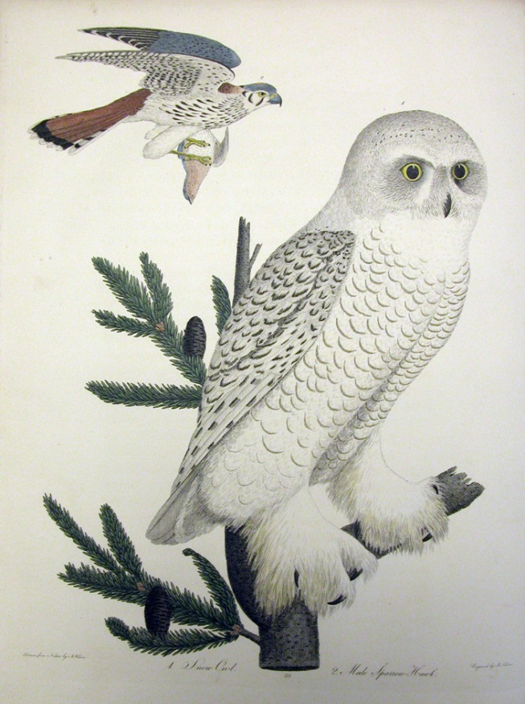
Figure –1
Snowy Owl
Alexander Wilson
1829
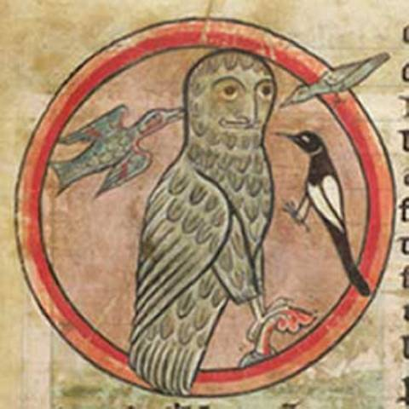
Figure 2
Bubo (owl)
British Library, Harley MS 4751, Folio 47r
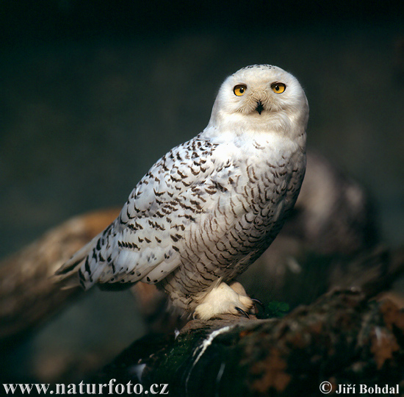
Figure 3
Snowy Owl
Photograph by Jiri Bohdal

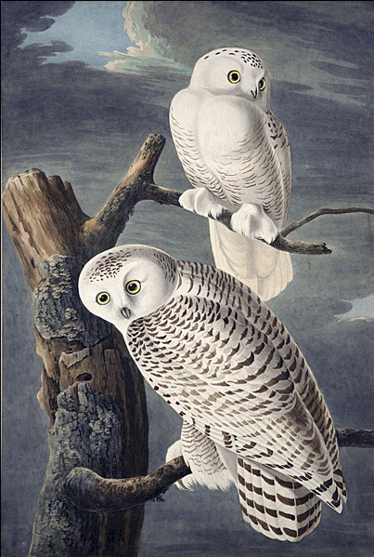
Figure 4
Snowy Owls
Birds of America
John James Audubon
1827-38
Hand-colored engraving
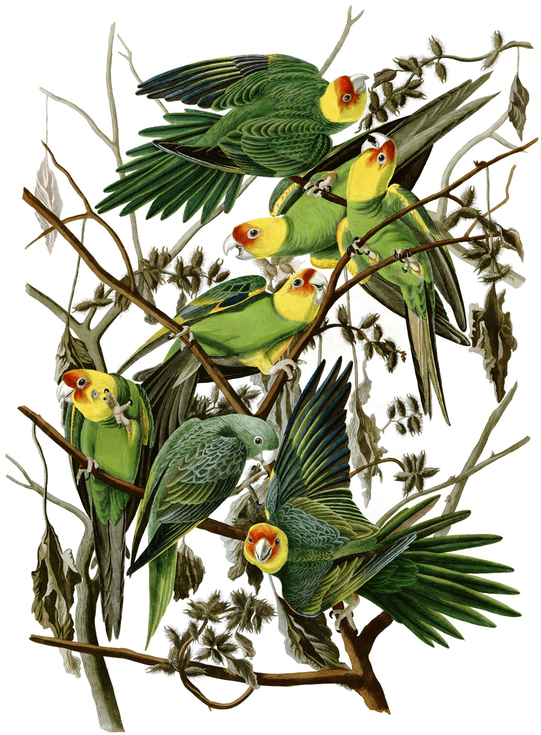
Figure 5
Carolina Parakeet (now extinct)
Plate 26 Birds of America
John James Audubon
1825
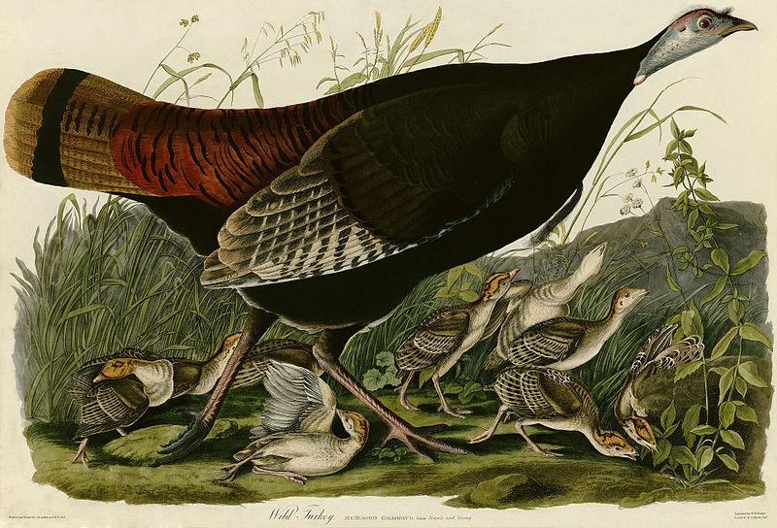
Figure 6
Wild Turkey (Female)
Plate 288 of Birds of America
John James Audubon 1840

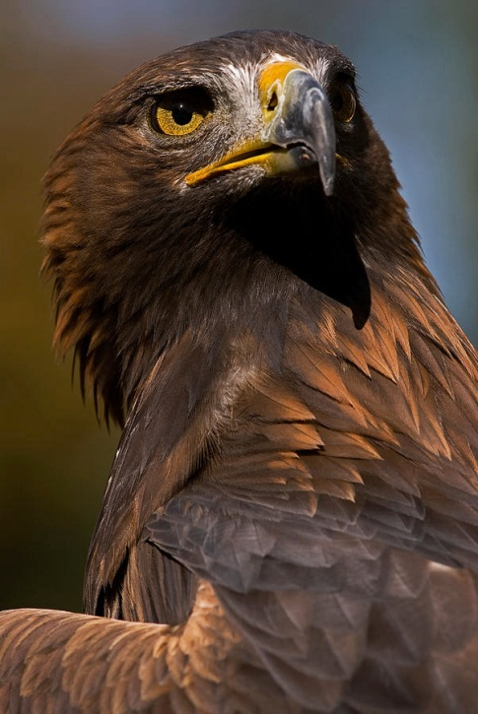
Figure 7
Golden Eagle
JT Lewis
Photograph 2011

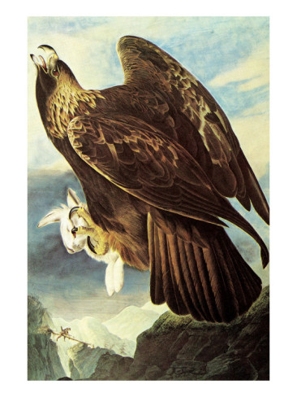
Figure 8
Golden Eagle
John James Audubon
1833-1834
Birds of America
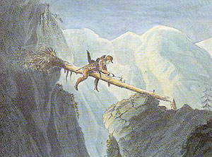
Figure 9
Golden Eagle- Detail of Self-portrait
John James Audubon
1833-1834
Birds of America

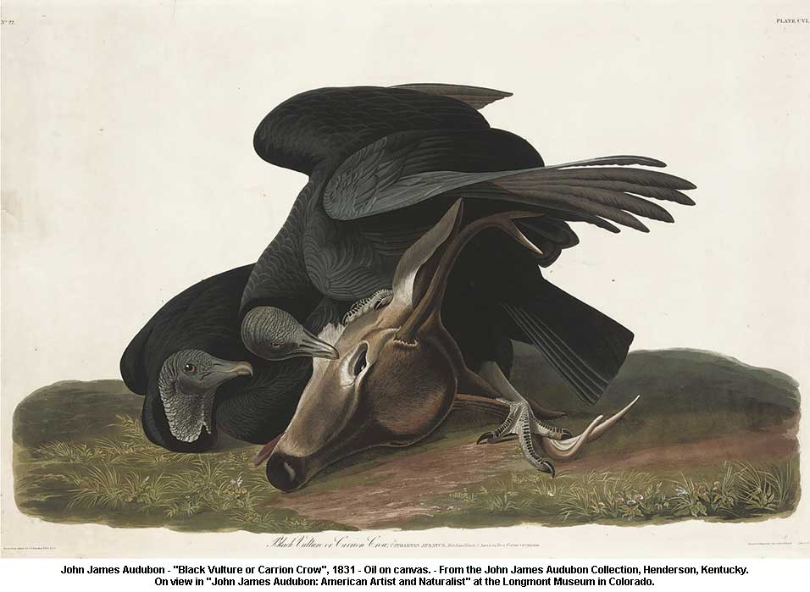
Figure 10
Black Vulture on Carrion Crow
Birds of America
John James Audubon
1831
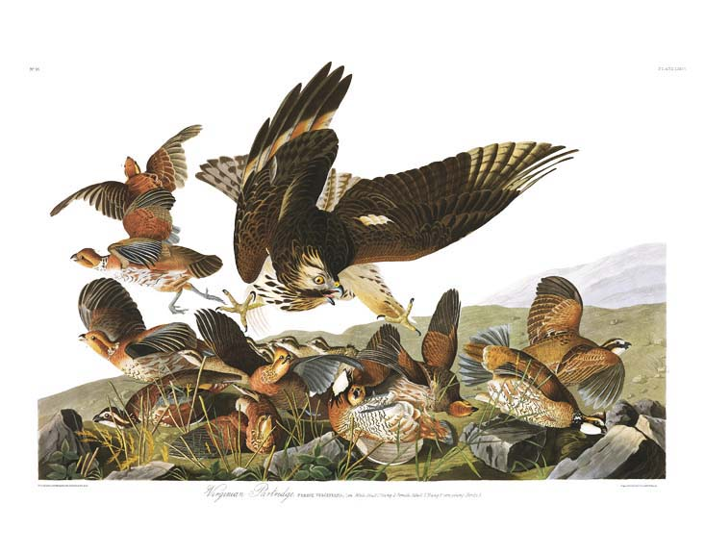
Figure 11
Virginian Partridge (Northern Bobwhite) under attack by a young red-shouldered hawk
Plate 76 from Birds of America
John James Audubon
1829
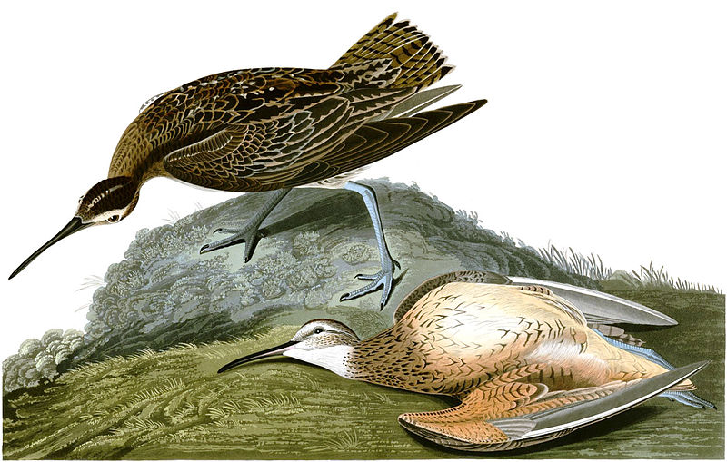
Figure 12
Eskimo Curlew
208 Birds of America
John James Audubon
1827-1838
Works Cited
Burroughs, J. (1902). John James Audubon. Boston: Small, Maynard & company.
Ford, A. (1969). Audubon By Himself. Garden City NY: The Natural History Press
“John James Audubon Timeline", American Masters, PBS
“John James Audubon: Drawn from Nature", American Masters, PBS
Punke, M. (2007). Last Stand: George Bird Grinnell, the Battle to Save the Buffalo, and the Birth of the New West. Smithsonian Books.
Rhodes, R. (2004). John James Audubon: The Making of an American. New York: Alfred A. Knopf.
Souder, W. (2005) Under a Wild Sky: John James Audubon and the Making of the Birds of America. New York: Macmillan.
Streshinsky, S. (1993). Audubon: Life and Art in the American Wilderness. New York: Villard Books.

