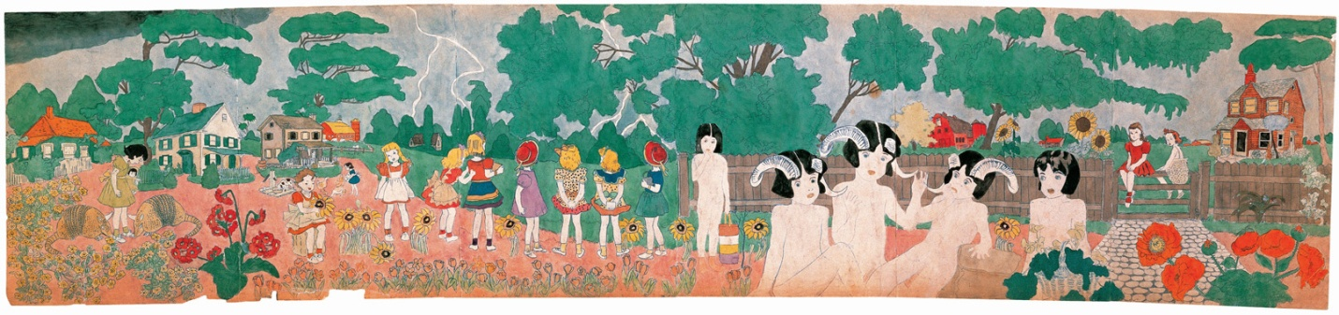

Henry Darger and His Vivian Girls

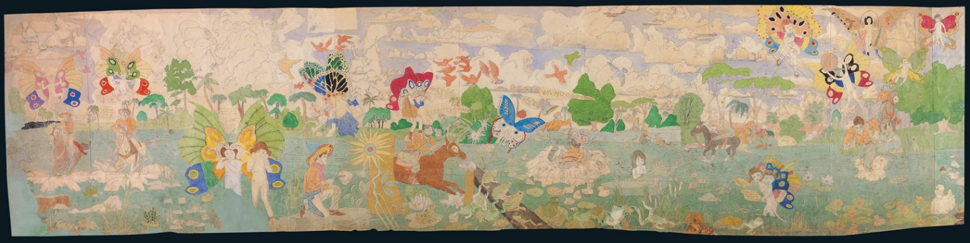

Libby McArthur
December 2010
Folk Art

Table of Contents

Title Page 1
Table of Contents 2
Introduction 3
Early Life of the Outsider 4
Darger the Artist 6
The Vivian Girls 7
Darger in Today’s Society 11
Conclusion 13
Figures 14
Works Cited 21

Introduction
The term outside artist was coined by the art critique Roger Cardinal in 1972. It is used to describe an artist who is known as self-taught or thought to be naïve. Basically these outside artists created art for art sakes. It was not a part of the mainstream art world. The artist in most cases would not become recognized until after his or her death. Often, outsider art illustrates extreme mental states, unconventional ideas, or elaborate fantasy worlds. Today Outsider Art has become one of the most marketable forms of art. The American Folk Art Museum opened its door in the early 1960’s has grown in size greatly every year and became a staple to the art scene in New York City, the art capital in the United States.
One of the most recognized and celebrated outsider artist is Chicago native Henry Darger ( Figure 1). After his death, his landlord, Nathan Lerner, a well known photographer, found several novels and artwork amid trash in Darger’s apartment. One of which was a novel with 15,000 of pages with text and illustrations, not only did they tell the tale of an epic battle of good and evil, but contained hundreds of illustrated drawings and watercolors to accompany his text. The single-spaced fantasy manuscript called The Story of the Vivian Girls, in What is known as the Realms of the Unreal, of the Glandeco-Angelinnian War Storm, Caused by the Child Slave Rebellion, with its several hundred drawings and watercolor paintings illustrating the story has become an outsider art icon and the subject of numerous books. This ghostly tale of war and a victory, hope and despair, and love and loss, creates a dream like animation that is still inspiring artist in the world today.
The Early Life of the Outsider
“(Born) in the month of April, on the 12th, in the year of 1892, of what weekday I never knew, as I never told, nor did I seek the information” (Darger). The quote is from the 8 volume autobiography that the artist had written over the last ten years of his life. It was found by his landlord, photographer Nathan Lerner, shortly before his death in 1973 at the age of 81.
Born in 1892, Darger had to grow up fast losing his mother from a fever just after giving birth to his sister. Due to his father disabilities, describe by the artist as being “lame”, (Darger) his sister was given up for adoption shortly after his mother’s death. Little Darger was living with his father in Chicago, Illinois. There he was given the task of going to the store and doing the shopping to support his allying father. By the age of ten, his father was placed in a home for the aging, and Darger found himself placed in the care of a Catholic boys home called Our mission of our Lady of Mercy. He was tormented by the other boys for making strange noises and wired behavior. He was eventually excommunicated from the school as he puts it “for being annoying”. A doctor he was taken to decided that he had mental illness, self-abuse, and his heart was in the wrong place. He was then sent to Lincoln, Illinois; to the Lincoln Asylum for Feeble-Minded children (Figure 2). At the asylum he was subject to harsh punishments and forced labor. Children would mostly spend days in the fields from seven in the morning till five at night with only a half hour break during the day. Little effort was put in to teacher the children via book. Several unusual events took place during his time at the asylum. Some of those events include, a child was ravaged by rats, a doctor died after attempting self-castration, and a teacher who would use inmate corpses as part of anatomy lessons while referring to the deceased by name. Ultimately, Darger escaped a year before the asylum was investigated for abuse (Park).
Once free, he found work as a janitor, attended daily Catholic Mass and lived a quiet solitary life in which almost no one knew him or noticed him. The tenants who lived with Darger at 851 W. Webster Avenue, in the Lincoln Park, said that he was a very quiet man who only remarked on the weather when talked to. He also would hold conversation with himself in his apartment that people could hear as they walked past his door. In the conversations Darger would use many different voices including little girls. He spent years like that in his apartment only coming out to attend church and go to his job as a janitor at the local hospital.
In April of 1973, in the last day of Darger’s life, his landlord, Nathan Lerner opened the door to his elderly tenant’s apartment (figure 3). The apartment Darger had lived in for over 40 years alone was covered with clutter and religious ornamentation. Among Darger’s personal affects Lerner and his wife discovered thousands of original works created in secret by the old man over the course of his life. Items that were found included: a 15,000 page work of fantasy fiction called The Story of the Vivian Girls, in What is Known as the Realms of the Unreal, of the Glandeco-Angelinian War Storm Caused by the Child Slave Rebellion; a 5,000 page autobiography entitled The History of my Life; a 10-year daily weather journal; assorted diaries; a 10,000 page novel entitled Crazy House; and Several hundred original illustrations and water color paintings depicting the plight of young children against oppressive and evil adults. (A.A.).
Under most other circumstances all of his artwork and stories would surely have been lost forever, however it is truly remarkable that an artist, Lerner would be the one to find and immediately recognized artistic merit of the thousands of illustrations of Darger’s books and paintings. Darger’s body now rests in All Saints Cemetery in Des Plaines, Illinois, in a plot called “The Old People of the Little Sisters of the Poor Plot.” Darger’s modest headstone is inscribed “Artist” and “Protector of Children.” (A.A.). (Figure 4)
Darger the Artist
The images that Darger produced were often violent, displaying brutal murders and torturing of the children in his stories. However they could also be very colorful, sincere, innocent, and playful. Using watercolor Darger creates a world of vibrant colors and creative patterns. (Figure 5). The American Folk Art Museum calls Darger “one of the most significant artists of the twentieth century”. His unique style has given rise to the term “Dargerism”.
His style seems to be uniquely his own. “Darger seems to have had little innate skill as a draftsman: he created his scroll-like paintings and drawing by means of collage, tracery, photocopying, and enlarging pictures” (Hand. 71). Most of his human figures were traced or collaged from popular magazines and children's books. (Figure 6). Some of his favorite figures to use were the Coppertone Girl and Little Annie Rooney which he collected from ads in newspapers and magazines. More than anything though Darger is praised for his gift of composition and the brilliant use of color in his watercolors paintings.
Most of his illustrations were pencil works on paper with watercolor and some collage done over the top of it. He also made textual annotations at the bottom of his paintings which were typical of his illustrations. The size of his artwork varied greatly. Some were drawn on sketchbook sized papers, while others were created to be mural sized work. Often Darger would join sheets of paper to create sheets that were 3-4 feet tall and 10-12 feet long. Due to the high number of large compositions, it became evident that Darger needed to create epic sized works that would adequate to create the dimensions of his visions. The price of artist materials were often high so it makes sense that Darger would create individual compositions on the front and back of these large canvases. Also the logistics of how Darger created these works because the size of his apartment was not very large and it would be hard to accommodate the large papers. The only conclusion plausible would be that he created his work in a scroll like manner or one length at a time. (Prokopoff).
The Vivian Girls
The origins of the epic, The Story of the Vivian Girls, in What is Known as the Realms of the Unreal, of the Glandeco-Angelinian War Storm Caused by the Child Slave Rebellion, appear to be between 1909 and then began to be typed in 1912. The 15,145 page, single spaced, type written book has drawn world recognition and an underground following in the art world. Not only did it become famous for the words that were written, but for the illustrations and subjects he created for himself. Combining his child hood love of watercolor and his catholic beliefs, Darger weaves a dramatic and classic tale of good versus evil in his self-created world.
The story tells the viewer about a world, which is unnamed and the earth is a moon, is home to the good Christian nation of Abbiennia. However the Glandelinians, who practice child slavery, try to enslave the Abbiennians. After hundreds of battles and many deaths the Glandelinians are forced to change their way, or not depending on which on the endings you read. In Darger’s world, abused children are avenged and innocence conquers all.
The heroines of Darger’s tale are seven Abbiennian princesses, known as the Vivian sisters (Figure 7). They are often aided in their struggle by their companion/secret brother, Penrod. These characters adventure through mortification, enslavement, torture, but are often aided, as Prokopoff calls them, "by panoply of heroes, who are sometimes the author's alter-egos." Called the “favorites of God” by the author the children are the true heroes of this tale.
Not only are there the main characters or the Abbiennians, Darger also creates an elaborate mythology which includes the species known as the "Blengigomeneans". They are known as the Blengins for short (Figure 8 & 9). They are gigantic winged beasts that have curved horns and are often portrayed as part human or they can even take a human form, disguising themselves as little girls. Darger portrays them as benevolent but they are very suspicious of all humans because of the child enslavers known as the Glandelinians. The artist writes, "They feel sure that any man, no matter what nation he is in, who ill-treats a little child, for whatever reason, is not only an enemy of children, but also an enemy of God. No man is safe in their presence who hurts a child" (Darger)
The Glandelinians are the antagonists of the story. They are from a godless empire of Glandelinia, who are a race of males bent on enslaving and killing children (Jones). Glandelinia is supposedly ruled by King Ganon Procile. The real power however is believed lies with General John Manley and his two sons Johnston and Heubam, who lead the massive Glandelinian army. Another famous Glandelinian, is the terrible Raymond Richardson Federal, the murderer of child-slave-rebellion leader Annie Aronburg. When drawing the villains, Darger portrays them as men of ages with hats that for resemble graduation hats (Figure 10). They carry guns and other weapons and usually have a scowl or angry face. They are known for their completely brutal behavior and vicious methods of torture. (Figures 12 and 13)
It is believed that Henry Darger called upon his experience in the children’s asylum in creating parts of The Story of the Vivian Girls. However the initial catalyst that started him writing is believe to be the portrait of Elsie Paroubek, a child who was murder at the age of five in Chicago (Figure 11). According to his autobiography, the picture was stolen out of his work locker among other valuable things and because he did not know the date he was unable to locate a new one. The death of the little five year old and the loss of the picture he had of her is said to have inspired him to start writing The Story of the Vivian Girls. Elsie Paroubek is believed to be one of the central characters in the novel known as Anna Aronburg (Park).
Darger surely drew upon his life experiences in his writings. The bizarre events that occurred during his time in the Lincoln, Home for Feeble-Minded children definitely influenced The Story of the Vivian Girls. McNett comments that “hundreds of millions of children and adults are destroyed by fire, flood, warfare, tornado, massive explosions and anything else you can think of” in a novel. A passage from The Story of the Vivian Girls, shows just how violent the novel becomes.
“The massacre continued for still another day. Children were dispatched in the most horrible manner. Their intestines were cut out, the Glandelinians even pelting their victims with them. Children were commanded to eat the hearts of the dead children, and those who refused were tortured beyond describing. The children were fairly bathed in blood” (Darger).

The elements of horror and violence and the level of action depicted, point more toward a working out of questions about his world. (Polanski). While walking back from the asylum Darger witnesses a huge tornado that devastates central Illinois. He uses his experience in this passage from The Story of the Vivian Girls.
“Way before Robert Vivian’s children were born, Hanson had a pretty daughter by the name of Violet Vivian. She herself was a regular Eva St. Clare and also died at the same age as Little Eva did. She was killed by the great typhoon which swept Abbieannia, as already described in the first few pages of this chapter.” (Darger)
The epic’s happy conclusion is only reached once the young princesses are tried by the most horrible events including martyrdom. Ominous creatures, great trials, storms, explosions, enslavement, torture, crucifixion, and humiliation are only a small part of what the Vivian girls endure so innocence can prevail. Epic battles rage with in the book that includes vivid detail and dramatic illustration of the incidents connected with it. The details in which the battles were recorded are meticulous. Darger even goes as far to create a list of the death describing them as “killed” or “mortally wounded”. One of these list he literally recorded thousands of names. Darger is said to have obtained a wealth of civil war military knowledge which helped him to create the scenes. (Prokopoff). Today the novel grows in popularity because it is one of the longest novels ever written.
Darger in Today’s Society
Darger never went to college and his high school education was grossly inadequate because of the time he spent at the Lincoln Asylum for Feebly-Minded children. Despite that fact, he displayed a writing style that was much more proficient then one would expect. Garret McNett raves about his writing ability and uses the following passage as an example of his superior writing skills.
"He paused for a moment, many recollections overpowering him. He seemed to have unlocked the casket of his heart, closed for so many hours, as if all the memories of the past and all the secrets of his heart and life were rushing out, glad to be free once more and grateful for the open air of sympathy" (Darger).
Many articles have also been written arguing whether or not Darger was mentally ill. John MacGregor speculated that Darger was sexually abused at the Lincoln Asylum. In his writing, Darger makes reference of hot, hard objects that are forced into the mouths of children (Moon). Much of his work depicts naked female girls with male genital. Moon suggests that it is not because he was obsessed with sex but rather that he did not know the difference between the male and female anatomy.
Other suggestions made of his illness are that he had Asperger’s syndrome, which a form of mild autism. In this syndrome, the person has trouble maintaining or even establishing human relationship, also are known to have obsession like behavior. They are most often fluent in vocabulary and of normal intelligence (Hand. 68). It would explain why he constantly talked about the weather or seemed a little odd around his neighbor. This could also account for the attention he gave to his books and paintings. However, according to Polanski, “psychologists such as Kay Redfield Jamison of John Hopkins University have demonstrated a higher incidence of mental illness among creative personalities, but many artists live well-adjusted lives, and a number have been highly successful”.
The first paintings discover by Nathan Lerner of Henry Darger were sold for only a few hundred dollars, however today Darger’s paintings has became more popular than Grandma Mosses work . His paintings now are fetching an upwards of $100,000 a piece. He is a perfect example of an outsider artist who crosses over into the contemporary art world. When Darger died he had no living heirs so Nathan Lerner and his wife became the benefactors of the Darger paintings, and have literally made two million dollars off the artist life works (Jones).
Besides the numerous amounts of poems, songs, band names, books, and movies. The Folk Art Museum in New York, has had several shows devoted to just him. One of the most recent was a reconstruction of the artist’s one room apartment (figure 14). Another is an exhibit which was based on the artist that have been influenced by Darger, in a movement known as Dargerism. Brooke Davis Anderson, curator of the exhibit said:
““Dargerism: Contemporary Artists and Henry Darger” examines the influence of Darger’s remarkable and cohesive oeuvre on eleven such artists, who are responding not only to the aesthetic beauty of Darger's mythic work—with its tales of good versus evil, its epic scope and complexity, and even its transgressive undertone—but to his unblinking work ethic and all-consuming devotion to artmaking.”
Conclusion
“If Darger’s fantasies often hovered on the fringes of sanity, his art enabled him to transform his obsessions into a luminous production that, in its best moments, transcends the pain and circumstances of its making” (Polanski). Henry Darger is an artist by default. He never intended to show his private world to the public. He would probably be more upset with the fact that the private world he created was being broken apart and sold off to the highest bidder. He is the epitome of doing art for art’s sake. The world he created was the result of endless hours and his life experiences. The novels and paintings ended up being his life-long companion. As viewers, we are lucky to have taken a glimpse into the world of Henry Darger.

Figures
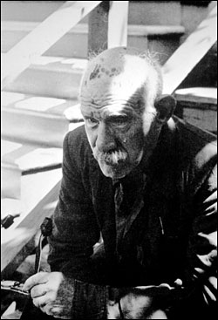
Henry Darger, ]taken by David Berglund in 1971. FIGURE 1
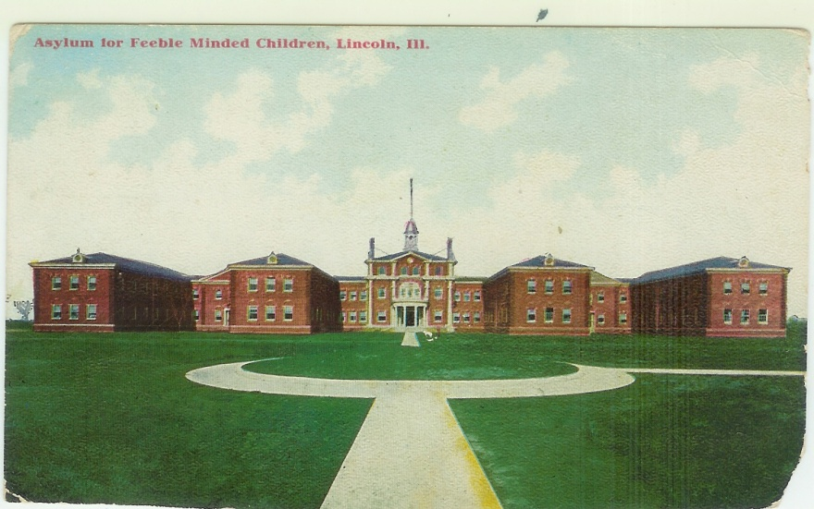
Asylum in Lincoln, IL. Figure 2
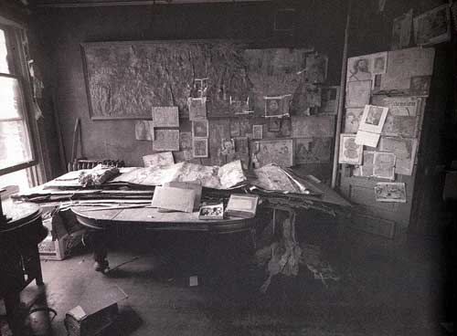
Henry Darger's one-room Chicago apartment. FIGURE 3
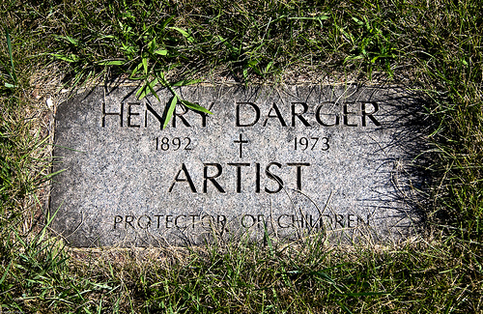
Henry Darger's Grave, All Saint's Cemetery, Des Plaines, Illinois. FIGURE 4

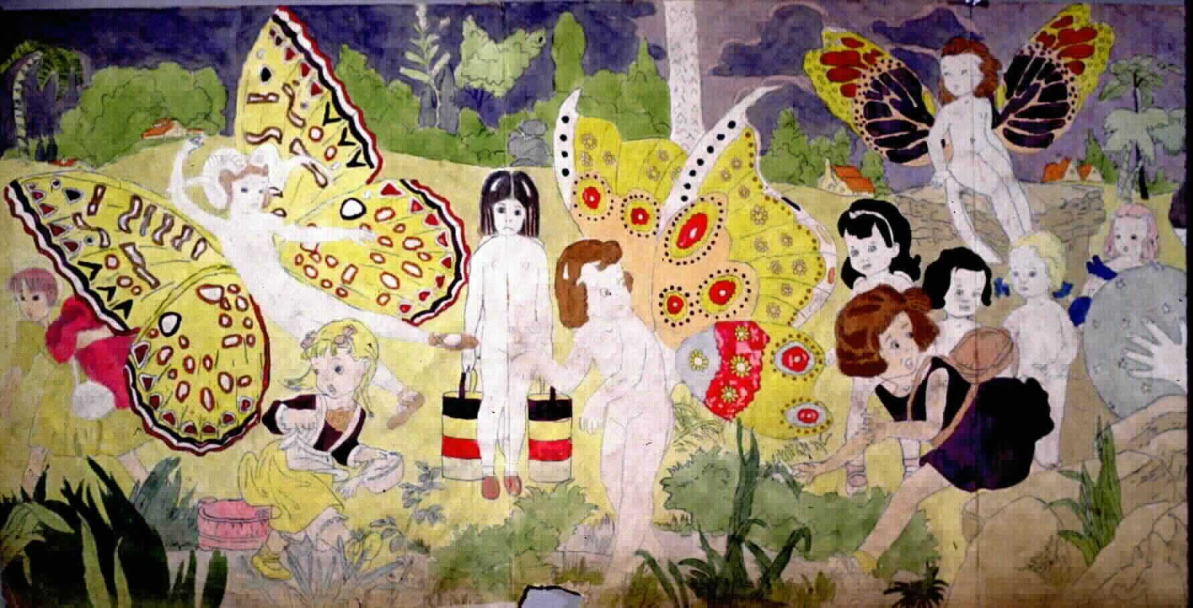
Illustration from The Story of the Vivian Girls by Henry Darger FIGURE 5
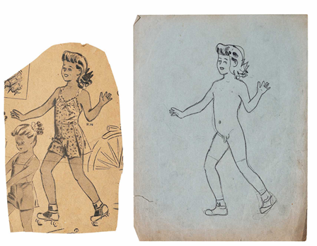
Tracing done by Darger. FIGURE 6
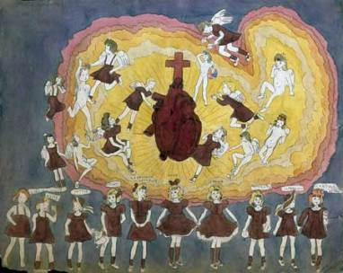

Henry Darger, Sacred Heart: Explosion (part one of diptych) FIGURE 7
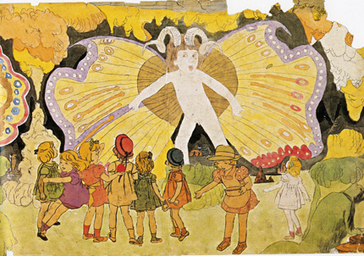
Other Blengin form. FIGURE 8

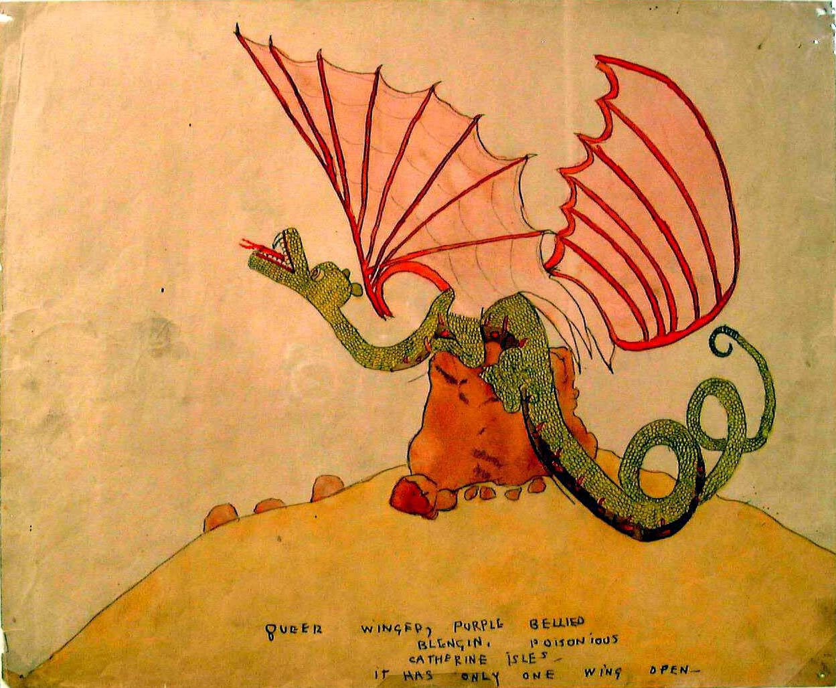
Blengin. FIGURE 9
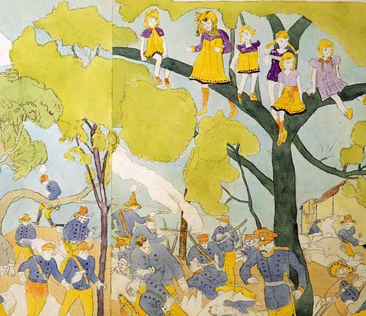

Glandelians. FIGURE 10

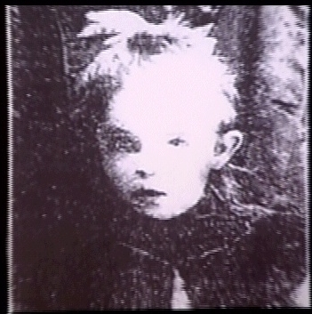
Picture of Elsie Paroubek who was murdered at the age of five in 1911 in Chicago. FIGURE 11

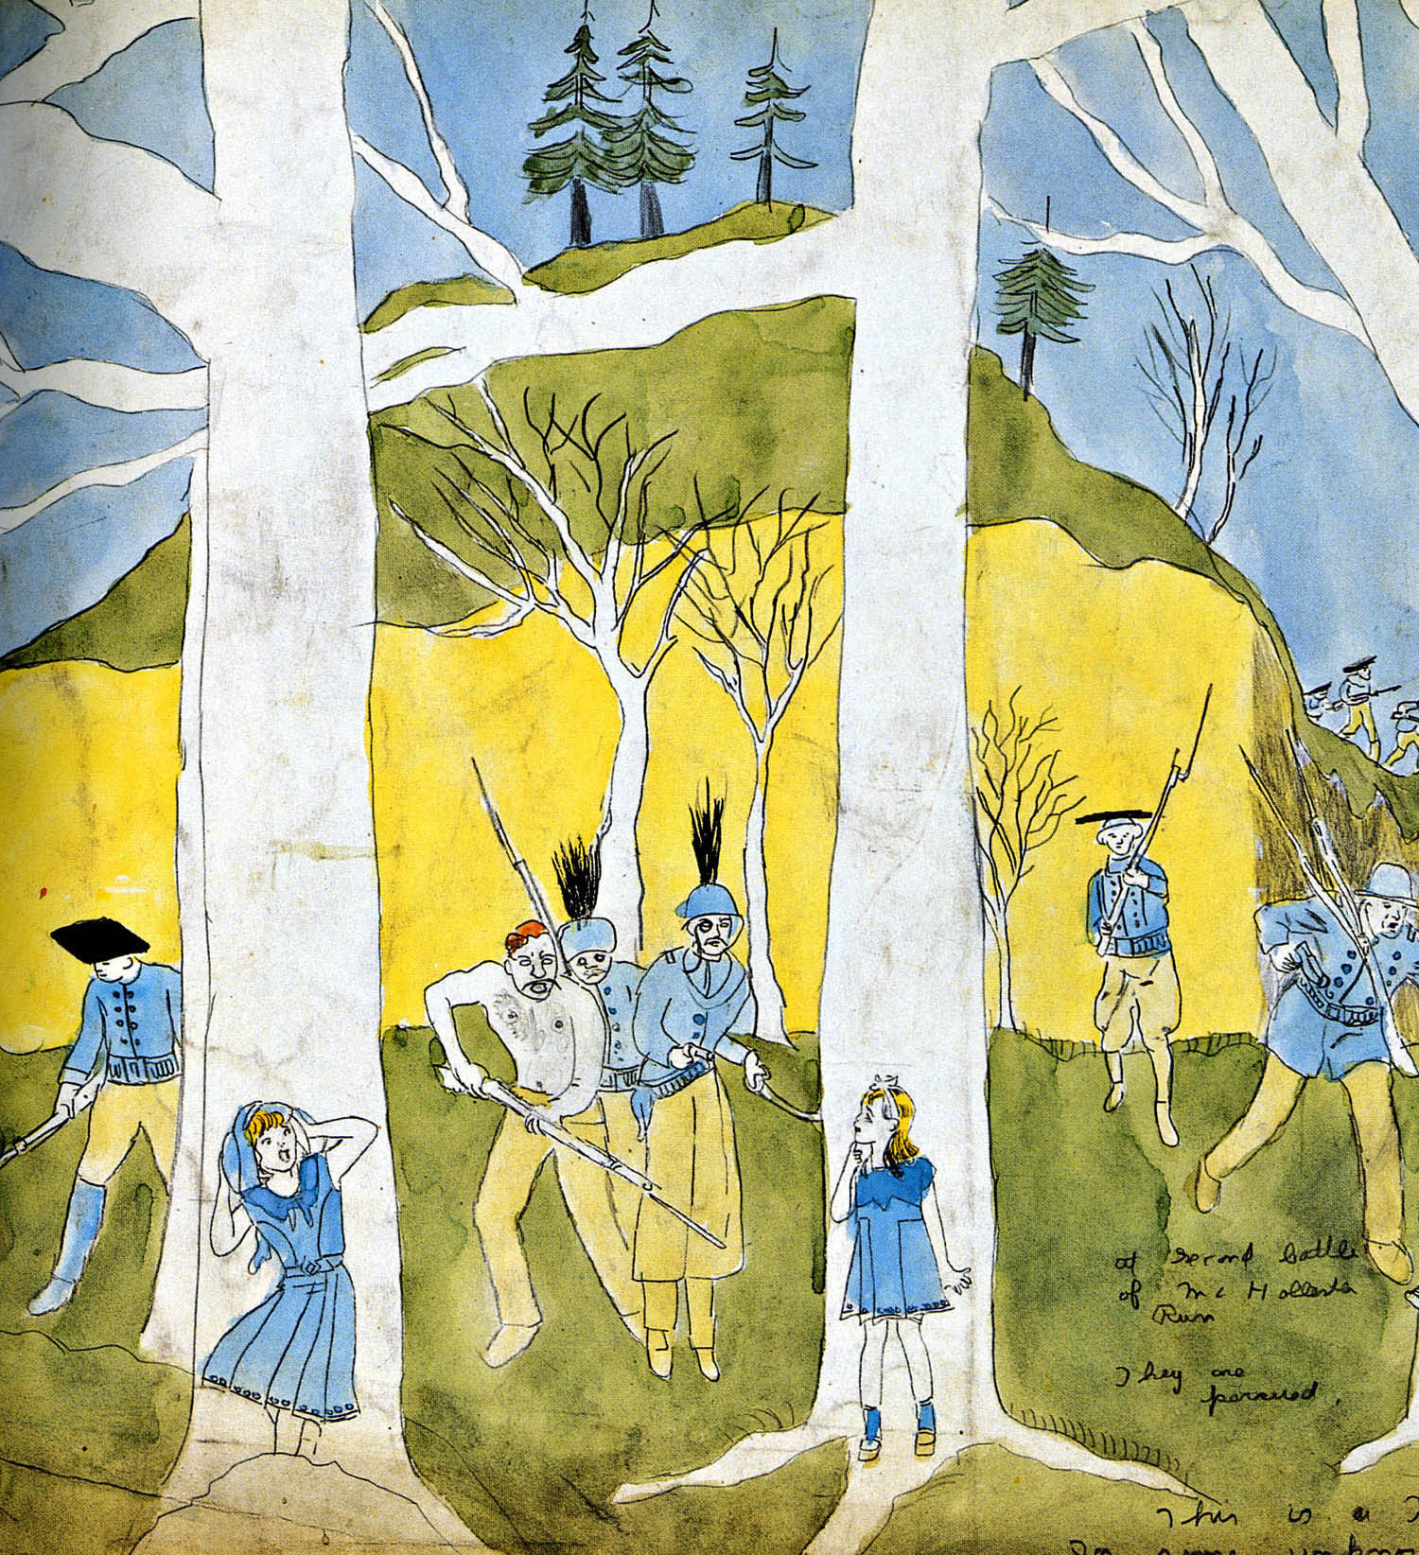
The Little girls hiding in the trees. FIGURE 12
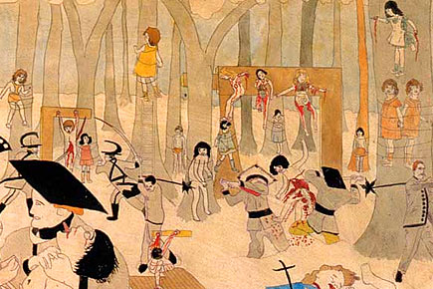
Killing scene from the Realms. FIGURE 13
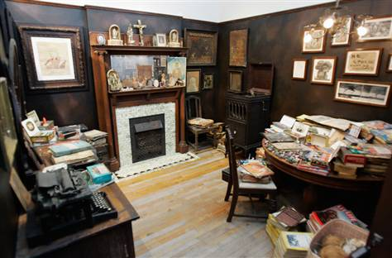
Recreation of his one room apartment. FIGURE 14

Works Cited

A.A. (2009 May 8). The Extraordinary Secret Life of Henry Darger. [Web log comment]. Retrieved from <http://spillspace.com/2009/secret-life-of-henry-darger/>
Darger, Henry. (1916). The Story of the Vivian Girls, in What is known as the Realms of the Unreal, of the Glandeco-Angelinnian War Storm, Caused by the Child Slave Rebellion. Chicago, IL
Darger, Henry. (1966). History of my Life. Chicago, IL
discofever. (2000, March 25). The Story of the Vivian Girls. [Web log comment]. Retrieved from <http://everything2.com/title/The+Story+of+the+Vivian+Girls>
Hand. Elizabeth. (2002). Books. Fantasy and Science Fiction. P.66-76. Books Now. Retrieved from EBSCO publishing.
Hughes, Robert. (1997, Febuary 24). A life of bizarre obsession. Time. Vol. 149, Issue 8. Retrieved from <http://web.ebscohost.com/ehost/detail?vid=9&hid=10&sid=7e34e711-aee0-4ad3-ae05-7f99ec52c6f%40sessionmgr13&bdata=JnNpdGU9ZWhvc3QtbGl2ZQ%3 d%3d#db=a9h&AN=9702206270>
Jones, Finn-Olaf, Forbes. (2005, April 25). WINDFALLS. Landlord's Fantasy. Vol. 175, Issue 9. Retrieved from <http://web.ebscohost.com/ehost/detail?vid=8&hid=10&sid=7e34e711-aee0-4ad3-ae05-77f99ec52c6f%40sessionmgr13&bdata=JnNpdGU9ZWhvc3QtbGl2 ZQ%3d%3d#db=a9h&AN=16712113#db=a9h&AN=16712113>
McNett, Gavin. (2003 July 7). A comment on "Henry Darger: In the Realms of the Unreal" by John M. MacGregor. Salon.com. Retrieved from <http://www.salon.com/books/review/2002/07/23/darger/print.html>
Moon, Michael. (2007). Do you smoke? Or, is there Life? After Sex? South Atlantic quarterly. 106:3. P. 533-542. Duke university Press.
N.A. (1997, Febuary 08). Darger's world. Economist. Vol. 342, Issue 8003. Retrieved from <http://web.ebscohost.com/ehost/detail?vid=8&hid=10&sid=7e34e711-aee0-4ad3-ae05-77f99ec52c6f%40sessionmgr13&bdata=JnNpdGU9ZWhvc3QtbGl2ZQ%3d %3d#db=a9h&AN=9702140946>

Park, Ed. (2002 April 12). John MacGregor Unlocks Henry Darger's Unreal Realm. The Outsiders. Retrieved from <http://www.villagevoice.com/2002-04-16/art/the-outsiders/>
Polanski, G. Jurek.( 2000). Henry Darger: Realms of the Unreal. Carl Hammer Gallery. Retrieved from < http://www.artscope.net/VAREVIEWS/Darger1000.shtml >
Prokopoff, Stephen. (2010 ). REALMS OF THE UNREAL. Carl Hammer Gallery. Retrieved from <http://www.hammergallery.com/Artists/darger/Darger.htm>

