Bo Nun Amuin:
The Sacred Masks of the Baule Culture

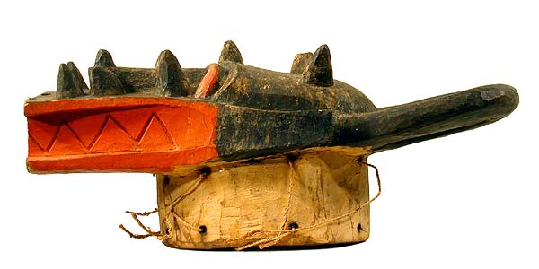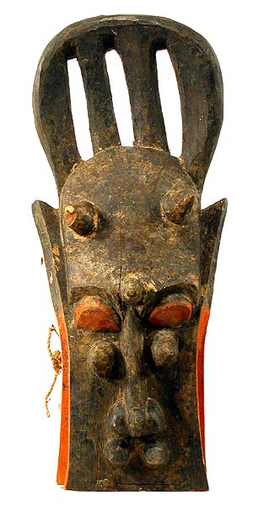

Libby McArthur
April 2010
African Art

Table of Contents

Title Page 1
Table of Contents 2
Introduction 3-4
Creation Myth 4-5
Baule Masks 5-9
Bo nun Amuin: Scared Masks 9-12
Connections 12
Conclusion 13
Figures 14
Works Cited 15-26

Introduction
Living in the Cote d'Ivoire and Ghana in Africa, is an ethnic group named the Baule (Figure 1). The Baule people are one of the largest ethnic groups at about one million people. They belong to the Kwa language group along which is part of the Atlantic-Congo within the Niger Congo linguistic group. The Baule people are neighbored by the Senufo, Malinke, Guro, and Asante peoples. These people are known for waging the longest war resistance to the French colonization of any Western African people. They also managed to maintain their traditional customs and practices longer than most group that come in constant contact with European traders, inhabitants, missionaries, and ambassadors (Tribal Africian Art).
The Baule people are primary located in eastern Cote d’Ivoire or the Ivory Coast between the Komoe and Bandama rivers (Baule Information).The area contains both savannah filled lands as well as forested areas. Most Baule peoples live in small farming villages were men and women work together to keep the village prosperous. Thier political structure is often referred to as a egalitarian society, which is characterized by premise is that people should be treated as equals on certain dimensions such as race, religion, ethnicity, political affiliation, economic status, social status, and cultural heritage (Arneson). The Baule society is separated into chiefdoms, each village is looked over by a senior council of elders which listens to the input of everyone in the society, including child and slaves. The women’s right to input is highly values and held at a sacred level. Even though women are a valued part of the Baule Society as we dive deep into the depth of the work of the Baule people’s art we will discover that women are not allowed all the same rights as their male counterparts. (Baule Information).
The Creation Myth
Just like many of the tribes of Africa there is a story of migration. The Baule origin myth begins in the 17th century in present day Ghana or the former Gold Coast. While the kingdom of Denkera rose to power there was a dispute, which lead a dynasty to leave the country. The queen or woman appointed queen named Abla Poku , according to Boyer her name varies depending on the version being told lead her people known as the Asabu through the forest and to a great river, the Comoe’. A diviner at the river told her she would need to sacrifice her only child to the river in order to ensure a safe crossing for her people. The queen eager to assist and protect her people threw her child into the water screaming “BAOULI!” or “My child is dead!”. It is then believed that the people adopted the name Baule in memory of their queen’s sacrifice for their safety (Boyer 12).
After the scarfice of the queen the story begins to get a bit muddled. Some believe that hippos rose out of the water a created a path for the people to migrate across the water safely. In another telling, a tree lowered itself across the banks to create a bridge for the people to travel across safely. Then, yet another talks about how the river parted a rocks appeared to create stepping stone to aid the fleeing people (Boyer 12).
Many people argue that this migration was not as vast as it is said but only certain higher ranking families took place in the migration. The rest of the million Baule people became assimilated for the people who were already in the region. Having a common ancestral history, in which the group is threatened by annihilation and had been over come by a character with strength the leadership, could then create a much stronger and united people. Over time this myth has been accepted as truth. Historians still argue the accuracy forming of this culture (Boyer 13-15).
The assimilation or merging of these cultures has created a explosion of traditions and art. Religion plays a large role in the creating of artifacts in the Baule culture. Their religion is a three tiered arrangement with a divine couple at the top, Nyamien (heaven) and Asie. The divine couple has removed themselves from the life of men and there for are not represented by masks and sculptures (Boyer 16-17). The second level consists of mediating divinities that are close to humans. The final level is made of spirits of nature the influence the everyday activities and personal lives of men and women. The middle stage is linked more with mature men, the hunters, farmers, etc… The bottom level is associated with the rest of the Baule society, which would include women, children, and adolescents (Boyer 16). The art of the Baule reflects the religious aspects of the societies’ beliefs, especially in their masks.

Baule Masks
In the Baule culture there are several different types of masks. Some Baule masks are associated with art that is performed, in other words they accompany a dance and have an entertainment component associated with them. The 2 types of masks that are carved for entertainment purposes are the Mblo and Goli Masks. The most important aesthetic of these entertainment masks is that their beauty and elegance is shown not when the object is stationary but when it is moving and swaying in the dances performed by the tribe members. The mask therefore is just an accessory of the performer. Susan Vogel, writer of Baule: African Art Western Eyes, explains, “few men and even fewer women ever had the opportunity to look at the carved mask without its costume” (136-137). Goli masks are kept in the bush while Mblo masks are kept inside the sleeping quarters of the dancer. It is placed carefully in a wrapped cloth to prevent women from seeing the mask’s back and to keep insects away. The most important factor is that concealment can heighten the impact of the mask when it performs.
Mblo Masks are one of the oldest in Baule traditions (Figure 2). They are portrait masks and are the most common piece of artwork found in Baule collections. The portraits are often associated with a know individual. Baule people believe that these types of mask have always existed and were said to have “emerged from the earth “ or ”descended from the sky” (Vogel 141). The characteristics of these masks are high foreheads, downcast eyes, and ornamentations. Ornaments are usually places above the face and in their hair. Different objects, like spoons, combs, birds, and pulleys are placed on the mask not for their iconographic significance but for their aesthetic beauty. Mblo are now starting to become old fashion and are beginning to become phased out of some villages. However every few years they will become recreated while new dancers are chosen to replace the aging one. This will reenergize the Mblo tradition. In the 1980’s, a new Mblo dance become prevalent called the Kpan Kpan. This involved masks that were no longer representations of a specific person, but instead a representation of political idea or group (Vogel 144-145). For example a ram to praise the president, a women with an elephant on her head for the Ivory Coast, and another women with a dove to represent peace among the people (Figure 3).
A common theme in Baule Art is opposite- sex doubling, where a pair of two masks will come out together, One representing the male side, the other the female. This is prevalent in the Goli dance, which is a day-long spectacle which will involve the whole village. Four masks will appear, musical instruments will be played, and lots of palm wine will be consumed (Vogel 169). This dance , adopted from the Wan people who live northwest of the Baule, is fairly new only about a 100 years in practice. This dance is gradually replacing the other dances of the Baule, whether scared or otherwise. It is performed for either entertainment or funerals of important men. The Kple Kple Masks are a favorite of European visitors because it is the A-Typical African masks. Also the entertainment factor does not upset the Christian converts like the bo nun amiun or scared mask performances. (Vogel 171).
The Baule version of the Goli dance consists of 4 pairs of masks appearing two at a time in a fixed order. Vogel writes, “first a pair of disk masks (usually called Kple Kple, next a pair of animal helmet masks (Goli Glen), third a pair of horned masks (Kpan Pre), and finally two human- faced masks with crested hairdos (Kpan)” (171). Spelling is varied with Kpan Pre also being called Kpwan Kple and Kpan also being known as Kpwan. Amongst the pairs, they represent the male and female. In the Kple Kple and the Kpan Pre, they are distinguished by color, red being male, and female being black (Figures 4 and 5). The difference in the Kpan and Goli Glen is minimal between the male and female masks, however in all the pairs the male mask will dance first (Vogel 171).
The Goli masks are much heavier than the traditional Baule portrait masks because they have to support the weight of the raffia costume that goes with it. The Kple Kple masks are representations of the junior society they are usually worn by young boys and the dance is said to be the easiest. These masks chase the other girls and boys around the village and will not perform during nighttime festivities (Boyer 46). The next set of masks to appear during the Goli dance is the Goli Glen. These masks represent the “father” or “ancestors”. It is whole head masks were the wearer places it over the entire head and gazes through holes in its gaping mouth (Figure 6). Goli Glen are animalistic masks the can combine the features of buffalo, antelope, and crocodile (Figure 7). This makes them a composite mask. The animal quality is brought to life by the dancers, while the stomp the ground, beat their backs, and intimate people in the audience (Boyer 48).
The Kpan Pre (Vogel) or the Kpwan Kple (Boyer) is the third pair to perform during the Goli dance. Boyer also comments that these are not present in all villages (49). The masks are humanistic in nature but have two horns placed on the top of their heads. They also, like the Kple Kple, vary in color based on the gender of the mask. Boyer writes, “it represents a transition between the untamed world embodied by the Goli Glen and the human world represented by the figure that is to follow, the Kpwan” (49).
Kpwan ,4th mask, according to Boyer represents the Goli Glen’s wife or the “Queen of the Goli Glen”. It can appear in pairs were the Kpwan will then take on the representation of family or child baring couples (49). It looks like a simple sleek face with a long straight nose that separates the eyes with drooping eyelids. The hair is in the standard pageboy coiffure or a single bun on the top of the hair and two side buns. It is the last and most important mask of the celebration (49). It is also used in child ceremonies and seen at the head of parades. It is a delicate and motherly persona.

Bo nun amuin Scared Masks
The Bo nun amuin (also known as Bonu amuin) masks are the most sacred in the Baule culture. Bo nun amuin can be translated to “gods risen from the bush” (Werness 42). According to Boyer, he writes, “the masks conjure up ambivalent supernatural power… although they are intrinsically dangerous they become tutelary gods if the rites are to their likings” (54). The Bo nun amuin protects the village from external threats and appears at funerals of important male notables, such as former dancers or chiefs. These supernatural masks aid the village at funeral times by helping the deceased to become ancestors that will aid in the village activities. These masks are also utilized in role of women in a Baule village. The masks are only allowed to be viewed by men, and a commonly used to discipline and threaten women with in the Baule culture.
These masks are considered sacred for a few reasons. One reason is that only few villagers are allowed to see them. It is not a secret brotherhood, any Boyer describes it as “conscientious” male member of the village may be become one of the members of the villagers to see the masks with having to pass a test (54). The main sign of sacredness comes from the fact that the mask maybe not be seen by women, not even western ones. During the performance anyone not allowed to see the masks, such as young children, teenagers, women, and visitors. This allows the women to know the Bo nun amuin by the sounds associated with them. The grunts, howls, of the bull-roarer are said by the men is the screeching of obscure spirits (Boyer 54-55).
Boyer outlines several reasons why women may not be able to see the Bo nun amuin masks, he asks that the reader then draws their own conclusions. The first reason is based in myth. The myth talks about a woman who comes across a creature in the forest and runs back to the village to tell the men of a creature she is afraid of. The men then talk to the creature and it agrees to help the village on two conditions. The first is that from now on to member of the female sex may be allowed to set eyes on it. Second, it would like an artist to carve a mask in its image because it would rather appear in the village as a carved double (55).
The second possible reason that the Bo nun amuin masks are not allowed to be viewed by woman is biological in nature. The masks are related to death therefore they may cause infertility in women. Women are said to be more susceptible to the effects of aggressive magic. It is said that women who accidentally see the mask are known to swell up in size and die within a few days. If she confesses to seeing the Bo nun Amuin masks then the proper rites and ceremonies are performed to heal the women (Boyer 55-56). Vogel claims that it is because poison is given to the women and then where confesses the antidote is administered.
The final reason given by Boyer is the one he call the most significant. He claims that women are the rival spirit to the men. The men cult sees the women cult or Ajanun as the more powerful cult. When men’s medicine fails the women are brought into cure the situations. The women do not need masks to perform their rituals. The women are the source of life and their private body parts are seen as divine. This ritual of Bo nun amuin is the only way the males can trump the female’s cult supremacy (55-56).
Decades before the present day, the masks were kept in secret shelters by the men’s latrines which were located a few hundred meters outside of the village. However due to the thieves, the masks have since been moved to under the beds of the dancers, and then be brought out to the woods the day before the ceremony. The men would appear naked in front of the masks in order to assure them of their gender. However now that European clothes have become a part of the culture the males will now drop their trousers once they approach the masks. Before crossing the shrine’s threshold palm wine or gin will be poured over it, and then spat onto the mask. This is to offer a piece of the wearer onto the mythical spirit. Before the 1970’s, prisoners were sacrificed to the spirit now animals such as dogs have been used instead. The brotherhood will eat parts of the sacrificial meat and then the heart and liver of the animal is spat out the mask. After the dancer is washed in water and herbs and has put on amulets around with hands and feet, blade shaped bark around his hands and knees, and rattles on his feet, brotherhood evokes the spirit with singing music before the mask can leave the shrine. After ceremonies are performed for the funeral or ceremony, usually towards the members of the public will yell out “K buno!” or “go back to the bush” for fear of the spirit staying to long (Boyer 57-58).
The forms of the Bo nun amuin can vary greatly. These masks have more of an animalistic feel of features than humanistic. Some of the most commonly used are masks with a single opened mouth. These mouths can vary greatly in themselves being opened or closed (Figure 11), fanged (Figure 9) or toothless, elongated and smiling, or even stylized (Figures 10). Horns can stretch out vertical and horizontally along with the ears which can also be broad or pinched out. This type is very similar to Goli Glen Masks. Another variation can be the double mouthed (Figure 12) while allows the spirit to see in all directions (Boyer 60).
The last types of masks are those with random elements attached. Figure 11 is one of these masks. It has a bird that is perched up on the forehead between the large ears that protrude from the masks head. Figures 9 and 10 also have some of these random elements with men and animals perched on the head and snout.
Connections
In the group of people to the North, there is also a tradition of ceremonial masks with a large horizontal pull. The Senufo people create composite masks of many animals. These masks, known as “kponungo” are funerary head masks. By outsiders they are referred to as “Firespitter” masks, because they will appear to be fire breathing because of the coal embers that are placed in the mouth of these masks. They are used by both Poro and non- Poro male societies which all adult male Senufo people are a member (Poro male Society). The masks embody the aggressive supernatural power that can disrupt the well-being of the village, which is very similar to the Baule’s Bo nun amuin masks. These masks combine the powers of many animals including antelopes, warthogs, hornbills, chameleons, and humans(Kliener). The mask shown in figure 13 has warthog like teeth, antelope shaped head and a chameleon perched on the top between horns
.
Conclusion
The Baule people of the Ivory Coast in Africa have many traditions which they have created and also inherited from the people surrounding them. The mblo masks are their most traditional masks and are usually idealized portraits of a real person. The Baule’s most common masks are made for entertainment purposes for the Goli dance. These masks come out in pairs and have a male and female counterpart denoted by color. The male mask always dances first. Anyone may look upon these masks.
However the Bo nu amuin masks are the most sacred. Only a select few of male society members may see let along wear this mask. It is terrifying for women and can cause illness and misfortune to all those who look upon it who are not allowed the right. These masks are a vital part of the culture of the Baule. The horizontal masks of the western African tribes influence and have similar meanings between the people. Unfortunately these scared masks are being shown to those who are not suppose to look upon them by the westerns who have entered these villages. Women are being allowed to view them masks in museums were African art is displayed. They are not even being stored outside anymore for fear of them being stolen. Some however are working to preserve the tradition and sacredness of these objects. Researchers and gallery owners have taken step to show these masks, with a written warning. This warning does not stop an individual from entering but atleast informs them of the culture’s wishes for them not to.

Works Cited

Arneson Richard, "Egalitarianism", The Stanford Encyclopedia of Philosophy (2002.) Web: http://plato.stanford.edu/entries/egalitarianism.

Baule Information. Art and Life in Africa Online: University of Iowa. 1998. Retrieved from http://www.uiowa.edu/~africart/toc/people/baule.html

Boyer, A. (2007). Baule; Visions of Africa. the University of California 2007

Kliener, F. and Mamiya C.(2009). Gardner's Art Through the Ages: Non-Western Perspectives. Ed. 13 revised. Cengage Learning, 2009

N/A. (1999). Tribal African Art: Baule, Ivory Coast. AFRICAN ART MUSEUM. On-line reference to the artistic styles of Africa. Retrieved from http://www.zyama.com/baule/index.htm

Poro Male Societies. (2011). Encyclopedia Britannica. Retrieved May 1, 2011, from Encyclopedia Britannica Online at http://www.britannica.com/EBchecked/topic/470652/Poro

Werness, H. (2003) The Continuum Encyclopedia of Native Art: Worldview, Symbolism, and Culture in Africa, Oceania, and North America. Continuum International Publishing Group. P. 42-43

Vogel, S. (1997). Baule: African art, Western eyes. Yale University Press. New Haven, Conn.

Figures
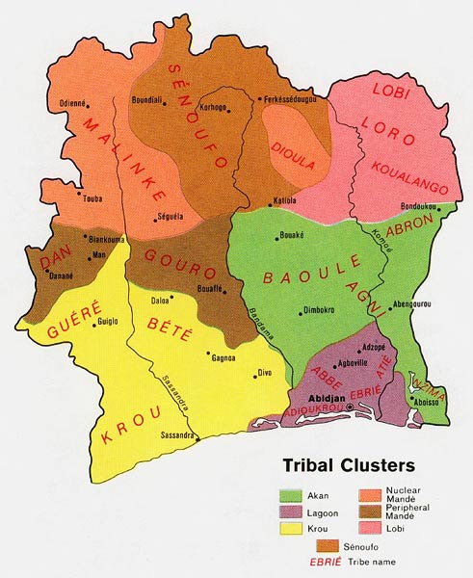Figure 1
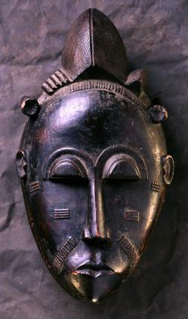 Mblo Mask Figure 2
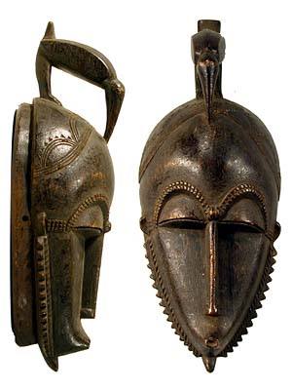Kpan Mask Figure 3
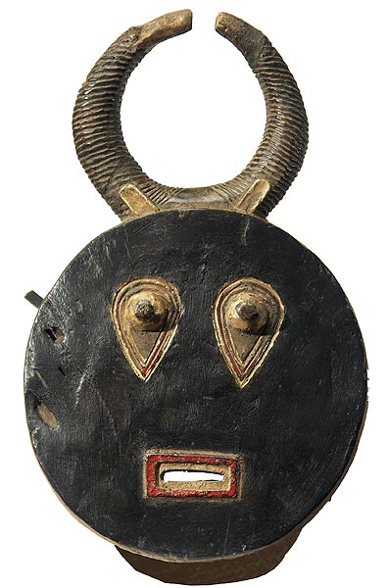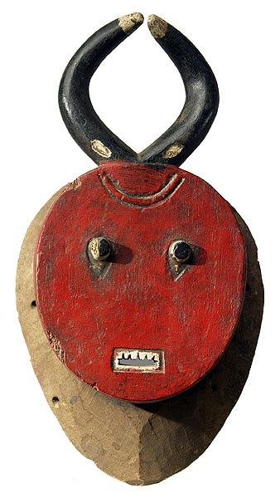
Kple Kple Figure 4
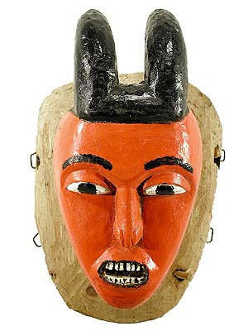male Kpan Pre Mask Figure 5
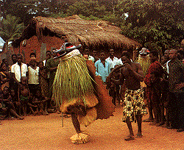
Goli Glen Dancers Figure 6

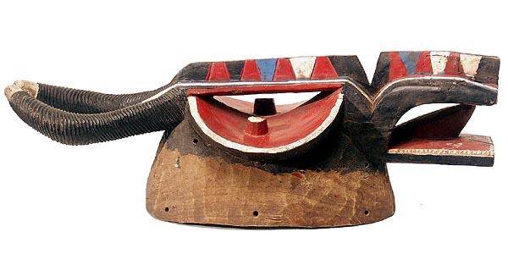Goli Glen Figure 7
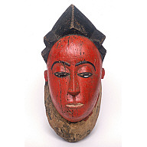Kpwan Figure 8

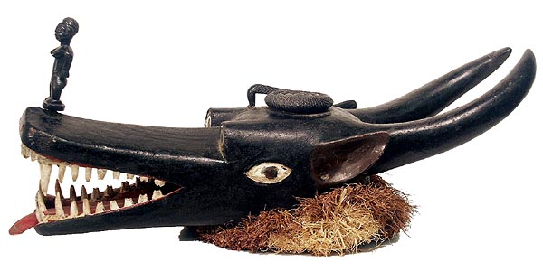Figure 9A
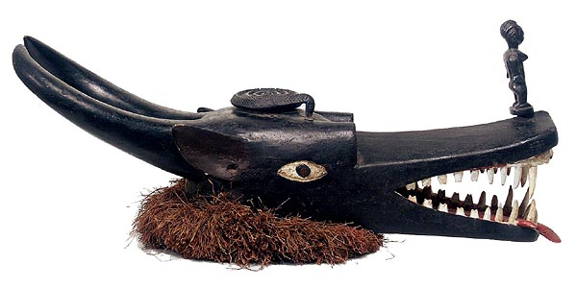Figure 9 B
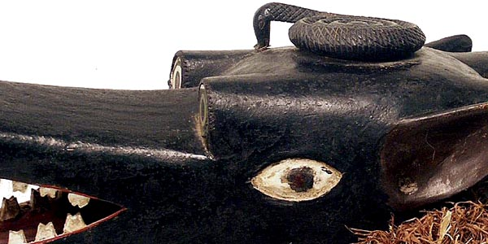 Figure 9 C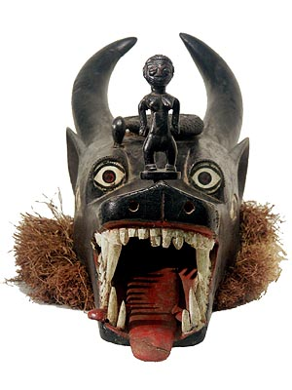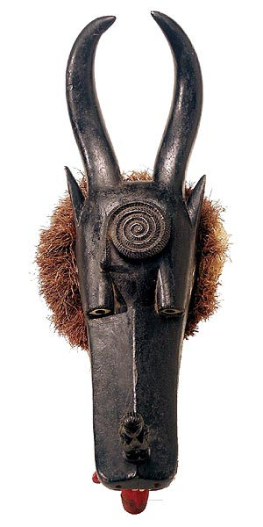
Figure 9 D Figure 9 E

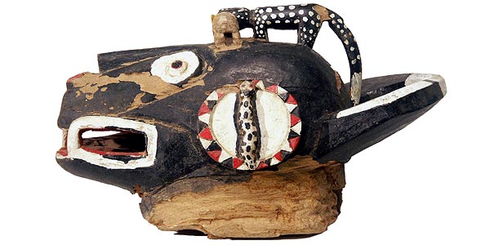Figure 10A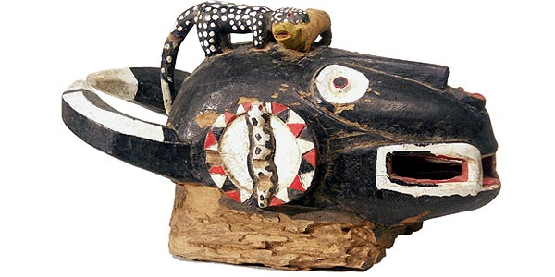Figure 10B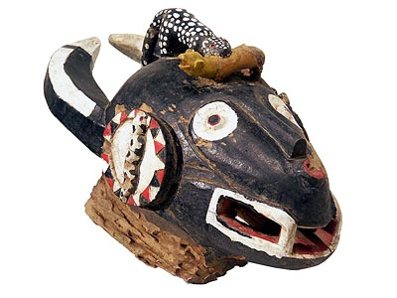Figure 10 C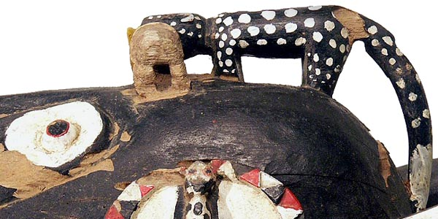Figure 10 D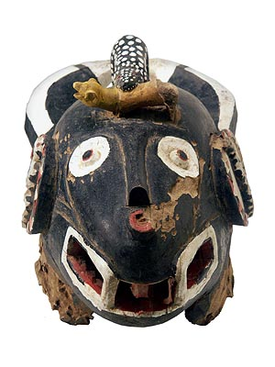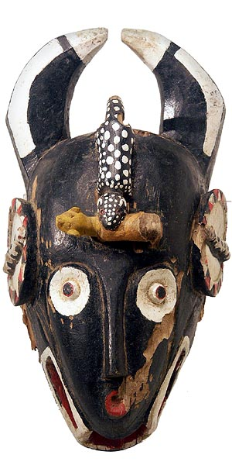 Figure 10E Figure 10 F

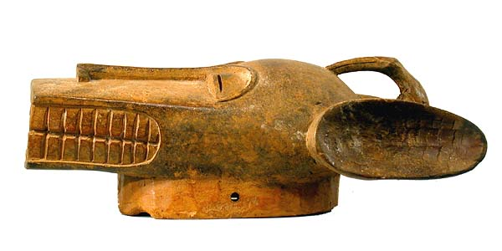Figure 11 A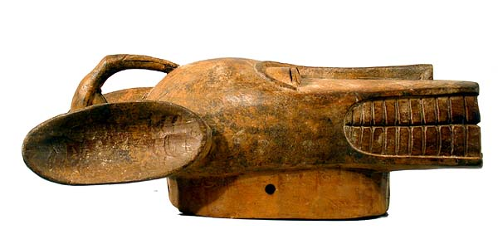Figure11 B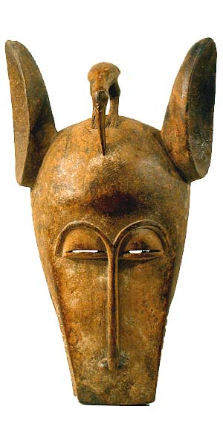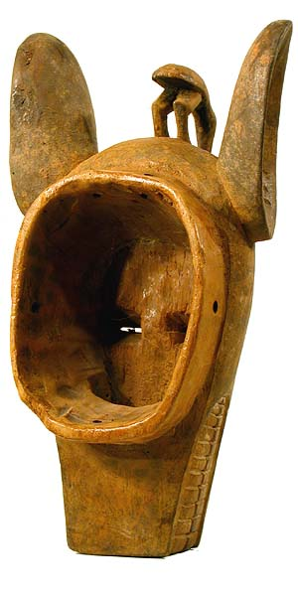
Figure 11 C Figure 11 D
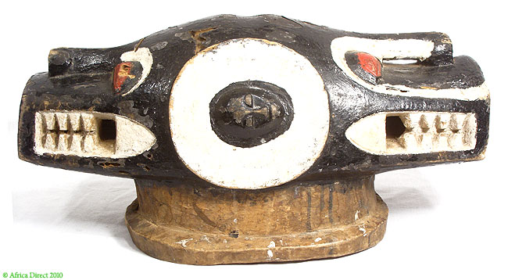Figure 12
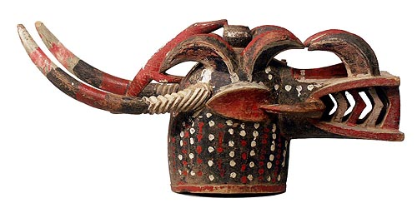
Figure 13 A
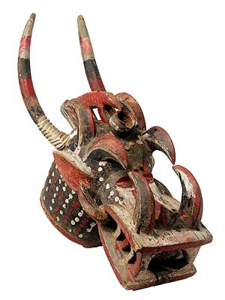 Figure 13 B

