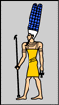  Amun | 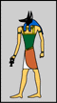  Anubis | 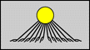  Aten | 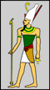  Atum
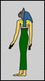  Bastet | 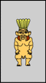  Bes | 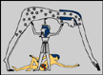  Geb | 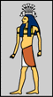  Hapy
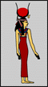  Hathor | 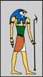  Horus | 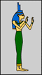  Isis | 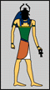  Khepri
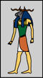  Khnum | 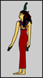  Ma'at | 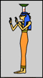  Nephthys | 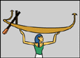  Nun
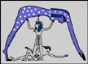  Nut | 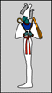  Osiris | 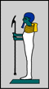  Ptah | 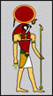  Ra
Ra-Horakhty | 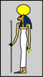  Sekhmet | 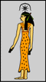  Seshat | 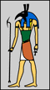  Seth
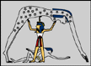  Shu | 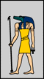  Sobek | 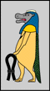  Tawaret | Tefnut
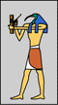
Thoth
God of. | Name | Appearence
Sun | Ra | head of falcon and sun disk
Music | Hathor | horns of cow and sun disk
Destruction | Sekhmet | head of lion
Sky | Nut | blue with golden stars
Earth | Geb | colour of plants and Nile mud
Dead | Osiris | dressed in white with crook and flail
Desert | Seth | animal head with long curved snout
Pharoah | Horus | head of hawk and crown of Egypt
Magic | Isis | throne on head or holding baby
Wisdom | Thoth | head of ibis
Embalming | Anubis | head of jackal
Justice | Ma'at | feather in her hair
Creation | Amun | crowned with feathers
Cats | Bastet | head of cat

Hieroglyphics Alphabet
