Blolo Bla:
The Baule Spirit Wife and Her Spouse, the Blolo Bian

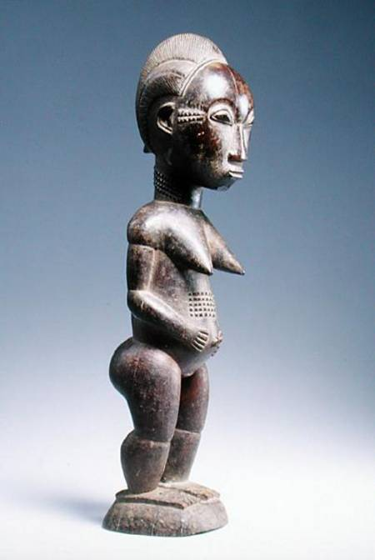

Libby McArthur
November 2012
African Art

Table of Contents

Title Page 1
Table of Contents 2
Introduction 3
The Baule People 3-4
Creation Myth 4-6
Statuary 6-7
Spirit-spouses 7-12
Conclusion 12-13
Works Cited 14
Figures 15-19

Introduction
In the Baule, statuary has become and integral part of the life and culture of the people. Many types of statuary exist among these people, from hunting aids, to forest spirits, divination guides, and even spirit spouses. Each statue is unique and made to serve a specific purpose and/ or person. The blolo bla and blolo bian or the spirit spouses carry a predominate role in the society of the Baule. The statues are individualized representing a connection of every single Baule has with a spouse in the outer world. The blolo bian and bla can control the happiness and interfere with the lives of the person here in our realm. However before discovering all the intrigue details associated with the spirit wives and husbands, it is important to recognize the history of the Baule in order to understand where these ideas where born.

The Baule People
Living in the Cote d'Ivoire and Ghana in Africa, is an ethnic group named the Baule (Figure 1). The Baule people are one of the largest ethnic groups at about one million people. They belong to the Kwa language group along which is part of the Atlantic-Congo within the Niger Congo linguistic group. The Baule people are neighbored by the Senufo, Malinke, Guro, and Asante peoples. These people are known for waging the longest war resistance to the French colonization of any Western African people. They also managed to maintain their traditional customs and practices longer than most group that come in constant contact with European traders, inhabitants, missionaries, and ambassadors (Tribal African Art).
The Baule people are primary located in eastern Cote d’Ivoire or the Ivory Coast between the Komoe and Bandama rivers (Baule Information).The area contains both savannah filled lands as well as forested areas. Most Baule peoples live in small farming villages were men and women work together to keep the village prosperous. Their political structure is often referred to as an egalitarian society, which is characterized by premise is that people should be treated as equals on certain dimensions such as race, religion, ethnicity, political affiliation, economic status, social status, and cultural heritage (Arneson). The Baule society is separated into chiefdoms, each village is looked over by a senior council of elders which listens to the input of everyone in the society, including child and slaves. The women’s right to input is highly values and held at a sacred level. Even though women are a valued part of the Baule Society as we dive deep into the depth of the work of the Baule people’s art we will discover that women are not allowed all the same rights as their male counterparts. (Baule Information).

The Creation Myth
Just like many of the tribes of Africa there is a story of migration. The Baule origin myth begins in the 17th century in present day Ghana or the former Gold Coast. While the kingdom of Denkera rose to power there was a dispute, which leads a dynasty to leave the country. The queen or woman appointed queen named Abla Poku , according to Boyer her name varies depending on the version being told lead her people known as the Asabu through the forest and to a great river, the Comoe’. A diviner at the river told her she would need to sacrifice her only child to the river in order to ensure a safe crossing for her people. The queen eager to assist and protect her people threw her child into the water screaming “BAOULI!” or “My child is dead!”. It is then believed that the people adopted the name Baule in memory of their queen’s sacrifice for their safety (Boyer, 2008)).
After the sacrifice of the queen the story begins to get a bit muddled. Some believe that hippos rose out of the water a created a path for the people to migrate across the water safely. In another telling, a tree lowered itself across the banks to create a bridge for the people to travel across safely. Then, yet another talks about how the river parted a rocks appeared to create stepping stone to aid the fleeing people (Boyer, 2008)).
Many people argue that this migration was not as vast as it is said but only certain higher ranking families took place in the migration. The rest of the million Baule people became assimilated for the people who were already in the region. Having a common ancestral history, in which the group is threatened by annihilation and had been overcome by a character with strength the leadership, could then create a much stronger and united people. Over time this myth has been accepted as truth. Historians still argue the accuracy forming of this culture (Boyer, 2008)).
The assimilation or merging of these cultures has created a explosion of traditions and art. Religion plays a large role in the creating of artifacts in the Baule culture. Their religion is a three tiered arrangement with a divine couple at the top, Nyamien (heaven) and Asie. The divine couple has removed themselves from the life of men and there for are not represented by masks and sculptures (Boyer, 2008)). The second level consists of mediating divinities that are close to humans. The final level is made of spirits of nature the influence the everyday activities and personal lives of men and women. The middle stage is linked more with mature men, the hunters, farmers, etc… The bottom level is associated with the rest of the Baule society, which would include women, children, and adolescents (Boyer, 2008). The art of the Baule reflects the religious aspects of the societies’ beliefs, especially in their masks.

Statuary
Baule Statues are referred to as “waka sran” which literally translates to “wooden beings”. Statuary figures are more common to the Baule and not the surrounding tribes of the Yaure, Mona, and Wan. Unlike their portrait masks that can sometimes bare a resemblance to a person, Baule statues features are not individually specific to a person. Their purpose is to take part in communication with spirits and to create a frame work to open those lines of conversation with the hereafter (Boyer, 2008).
The Baule artists create figures in which every elements, every feature has a purpose and function. It is the words that spoken wordlessly to help connect the person with the statue (Boyer, 2008). There are five difference types of Baule sculptures that are made for specific task and for different aspects of tribe life. Each type is carved with specific specifications and functions in mind. Not all are for similar performances, it is quite the contrary. Each is specific and serves a different role with in the Baule way of life. For the private home, the Baule turn to blolo bla and blolo bian (Figure 2 and 3), or the spirit spouses. Other statues are more public like the asie usu (Figure 4) and the komyen, which are divination statues. These are seen as divination dancers and spirits of nature. The dog headed statues (Figure 5), known as Aboya and Mbotumbo, are also divination statues but are linked to death. The last form of Baule statuary are the Bo usu (Figure 6), which are hunting statues and have to do with the deep forest. No matter the type of sculpture the Baule hold them with great regard.

Spirit-spouses
In a parallel universe lives a spirit spouse called the blolo bla (wife) and blolo bian (husband)(Figures 2 and 3). These spirit spouses live in a shadowy place running alongside the people of the Baule. The Baule see it as a “hazy, vague, uncertain place” (Boyer 21). When there is a celebration of birth here, it seems that the blolo spouses or other place will mourn the loss of its own. The places are connected by the cycle of life and death, in some cases the person is reincarnated in a birth and the ancestor can be recognized and is called “little ancestor” or umien sran.
The Baule believe that before one is born they form an attachment with their “real” wife or “husband”. This does not become apparent until the child reaches the teenage years from between thirteen to sixteen. During this time the child begins to become convinced that he or she is sleeping with an unknown of the opposite sex with leads to fantasies and nocturnal discharges. This first meeting is sometimes seen as a source of anxiety but the adolescent soon realizes they cannot be without the other spirit (Boyer, 2008).
When a person of the Baule marries, it is physical and for the procreation of the species. However if the blolo bla or blolo bian are not satisfied or not remembered then it will become jealous. This jealousy can result in the casting of evil spells by the blolo bla or blolo bian. This could be things like impotence in the husband or sterility in the wife. A Baule diviner would be asked to step in a try to untangle the threads and try to figure out the cause of the blolo revenge. Sometimes the revenge can be turned around if the spouse acts in a specific manner to appease the jilted spirit. In most cases the spirit spouse will ask for a statue carved in the spirit’s true likeness (Vogel, 1997). The diviner gives specific instructions for how the blolo bian or bla should look, because he is able to communicate with the other world (Boyer, 2008). A ceremony would then be held to introduce the spirit spouse to the village and the other members of the family. In most cases the statue is given a meal and served first. This consists of a white hen, palm wine, and food that are placed on a plate in front of the statue. Boyer writes that the spirit spouse likes “the morsels it is particularly fond of, in other words precisely those things that humans don’t eat- the head, entrails and feet” (25).
The new statue of the blolo bian or blolo bla is then placed in the room of the owner(Vogel, 1997). Usually it is placed in a corner behind some offering jugs and draped with a white cloth. It can also be hanging in the room suspended with cloth. The earth bond spouse would spend one day a week, usually Fridays, eating alone in their room to have an intimate dinner and night with their spirit spouse. This is the case even if the earth bond spouse is married; the married partner will spend the night in another room or house (Ravenhill, 1980). When asking the spirit spouse for something important the statue is rubbed down with kaolin with is white clay. Some statuettes, like Figure 7, stayed whiten from this act. If you notice around the blolo bla (Figure 7) it retained the kaolin mask around the eyes which is visible because of the white residue.
This object is not only looked at but touched, the earthly spouse takes great care in making sure the surface of its carved mate is taken care of properly. Females have been known to perfume their blolo bian to keep their spouse smelling sweet (Boyer, 2008). It is important to make sure that the spirit spouse is pleased with its own carving. If it is not pleased it will cause the earthly spouse to still have problems with fertility and in their love life. However, if the carving is stolen it is not a horrible ordeal, a new would be made by the same sculpture but does not necessarily needs to look like the first (Boyer, 2008).
To the Baule, a woman is not truly considered a woman until she bares a child, so technically a woman is not a woman until she becomes a mother (Boyer, 2008). For this reason many blolo bla are depicted having a pregnant appearance like Figure 8. This blolo bla sculpture swells in the middle area, giving it an appearance of a swollen stomach. Her hand rests on her abdomen making it appear that she is cradling the new life within her. This carving is unlike Figure 7, which hold its arms behind its back and has a longer and leaner appearance.
Despite the purpose of fertility but the spirit figure reach into other facets of Baule life (Ravenhill, 1980). The spirit spouse becomes a symbol of family unity. It also allows the earthy partner to feel more confident about being social around others as long as its blolo spouse is happy. After a woman reaches an age when she is done having children she will sometimes give her blolo bian to her grandchildren to cuddle. It is sometimes also seen as a guardian angel or spirit protector who sits in the house and watches over the occupants. When a person dies the spirit of the blolo bla or blolo bian leaves the host statue returning to the other side with its earthly spouse. The carved statue remains with that person’s other belongs or is passed on through people of the family. They are also sometimes given as gifts to people who have done things to help the family out (Boyer, 2008).
The blolo bla style of sculpture is similar to the other Baule statuary. These features would include slightly bend legs, thin long necks, almond shaped or round eyes, and scarification markings on their bodies. The blolo bla or spirit wives have pointed breast that can either be protruding out from their bodies or lying flat on their chests. With the consultation of a diviner the scarification, posture, and dress would all be added (Ravenhill, 1980). When looking at the hand position of the spirit wife, they are usually clasped on the stomach; however some arms are placed behind the back. It seems that never do the arms appear to be away from the body. In Vogel’s “Baule: African art, Western eyes”, some blolo bian and blolo bla appear to be painted and dressed in more contemporary apparel (1997). Figure 9 appears to wear a painted on skirt and shoes, as well as a painted on bra like top, if not just painted breasts with painted dots adorning the top of her chest near her collar bones.
The Baule blolo bla of Figure 10 is a typical example of the spirit wife. Her pointed breast stretch out away from the crest and are very apparent. It looks as if the breasts take over the shoulder and recede straight into the bicep of the wife. Her large head is typical of most blolo bla. The hairstyle of the wife is pointed and elaborate, as it jets high of the head into an almost cone like shape. Figure 8 also depicts this hairstyle while Figure 2’s hair is a bit more elaborate as it is divided into 3 pointed sections. The scarification and facial details are the work of the diviner who advised the artist to create it. Many blolo bla bear the marks of scarification on either their stomachs, chests, and/or faces are also typical for these statues. The feet of the blolo range from flat and wide, to small and pudgy, but seem to always be placed on a pedestal.
Not every Baule has a blolo bla or bian. Sometimes a person will chose to not have one made. This could because it was never advised by a diviner or needed to ensure the happiness of this world’s person. Vogel gives the example of a dancer who is happily married to two wives for many years with 9 kids. He chose not to create a blolo bla because “establishing a spirit spouse shrine will cost more effort and money than it is worth” (249). Vogel also talks about children who care for their parent’s spirit spouses in order to connect with their parents, which is another interesting concept. Some children even view them as their spirit parent (Vogel, 1997). Whether a Baule decided to have one or not it is obvious that the spirit spouses of the Baule are not only an important part of their artwork but also of their lives.

Conclusion
The Baule people of the Ivory Coast in Africa have many traditions in their artwork. One of the most common art forms the Baule are known for are in their statuary. There are five difference types of Baule sculptures. Each type is carved with specific specifications and functions in mind. Blolo bla and blolo bian are the spirit spouses of all Baule. Other statues are asie usu, komyen, Bo usu, and the dog headed statues, known as Aboya and Mbotumbo. This paper focuses on the importance of the blolo bla and bian and how they contribute to Baule society.
To the person, the spirit life is their connection to the outer world. It helps them in love and with the bearing of children but can also behave poorly if neglected by its earthly spouse. If a person is having relationship or fertility issues, a diviner would be called in to help the person with their blolo spouse and its creation. The look of each spirit spouse is unique and is specific to the person that it is created for. These statues become an integral part of Baule society and life. They are even given their own day of the week in which the earthly spouse spends dinner with them and sleeps besides them. They are always in the house of the spouse and always on their minds. However, no matter the type of sculpture the Baule hold them with great regard.

Works Cited
Arneson Richard, "Egalitarianism", The Stanford Encyclopedia of Philosophy (2002.) Web: http://plato.stanford.edu/entries/egalitarianism.

Baule Information. Art and Life in Africa Online: University of Iowa. 1998. Retrieved from http://www.uiowa.edu/~africart/toc/people/baule.html

Boyer, A. (2008). Baule; Visions of Africa. the University of California 2008

Kliener, F. and Mamiya C.(2009). Gardner's Art Through the Ages: Non-Western Perspectives. Ed. 13 revised. Cengage Learning, 2009

N/A. (1999). Tribal African Art: Baule, Ivory Coast. AFRICAN ART MUSEUM. On-line reference to the artistic styles of Africa. Retrieved from http://www.zyama.com/baule/index.htm

Poro Male Societies. (2011). Encyclopedia Britannica. Retrieved May 1, 2011, from Encyclopedia Britannica Online at http://www.britannica.com/EBchecked/topic/470652/Poro

Ravenhill, Philip L.Vogel, Susan Mullin. (1980) Baule statuary art :meaning and modernization Philadelphia : Institute for the Study of Human Issues,

Werness, H. (2003) The Continuum Encyclopedia of Native Art: Worldview, Symbolism, and Culture in Africa, Oceania, and North America. Continuum International Publishing Group. P. 42-43

Vogel, S. (1997). Baule: African art, Western eyes. Yale University Press. New Haven, Conn.

Figures
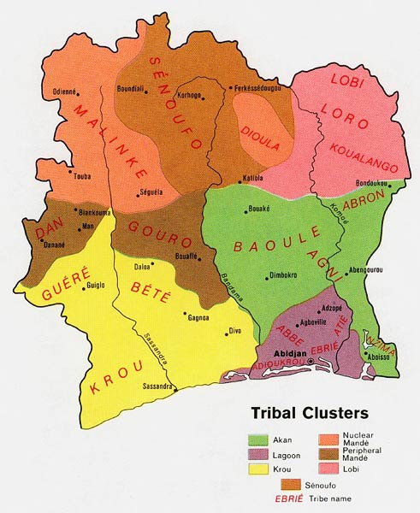
Figure 1
Map of Baule Area
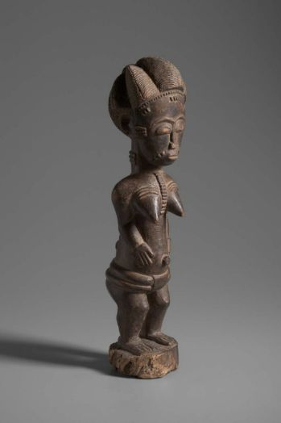
Figure 2
Baule Blolo Bla
Wood
20th century, 1950–75
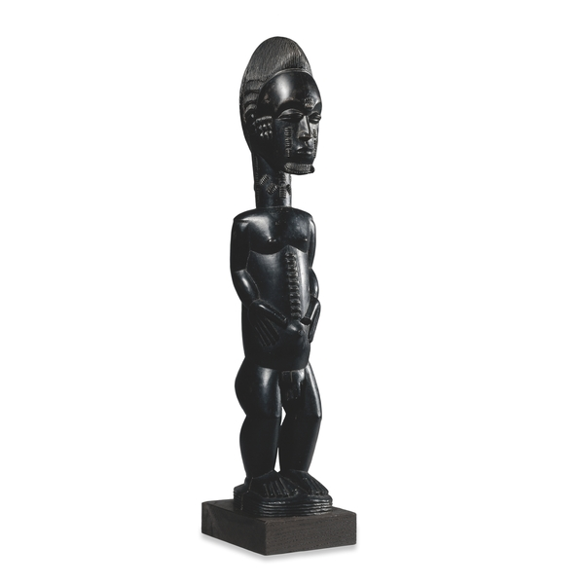
Figure 3
Baule Blolo Bian
Wood
Late 19th century AD
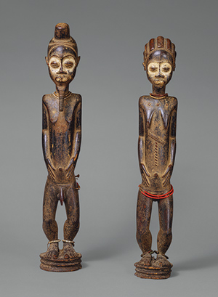
Figure 4
Baule asie usu
Wood, pigment, beads, iron
19th/20th century AD
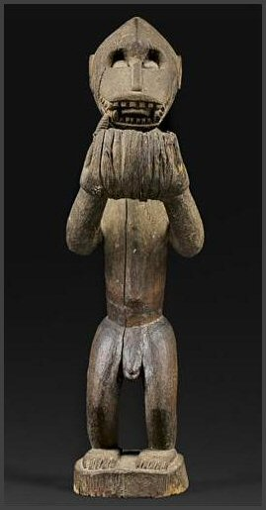
Figure 5
Baule Aboya
Wood
19th/20th century AD
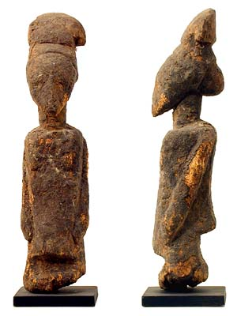
Figure 6
Baule Bo usu
Wood
19th/20th century AD
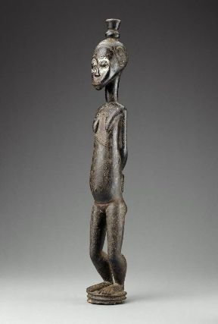
Figure 7
Baule Blolo Bla
Wood and kaolin
20th century

Figure 8
Baule Blolo Bla
Wood
19th century

Figure 9
Baule Blolo Bla
Wood and pigment
Mid-20th Century
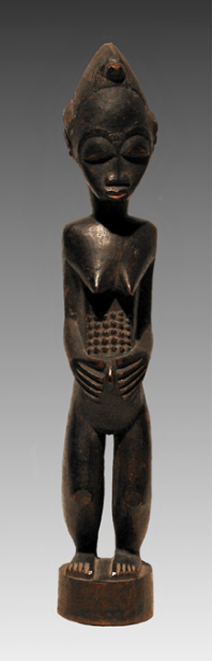
Figure 10
Baule Blolo Bla
Wood
Late 19th Century

